**Phase I – Sign Up For Demo Website**

Signed up at <https://orgfarm-signup-ef74ec99e750.herokuapp.com/signup>

This is the demo site from Dreamforce, which John Johnson recently attended and learned about the upcoming Agentforce technology(recently rebranded from Einstein Copilot).

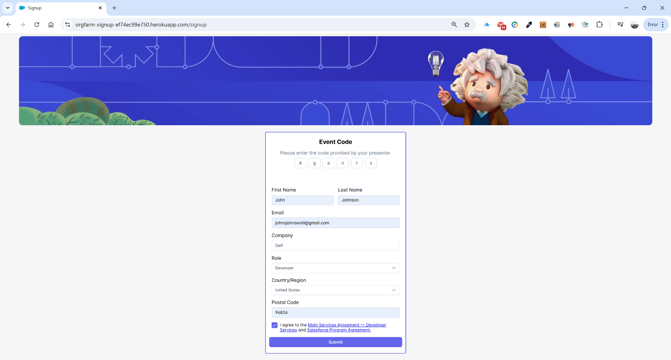

After signing up, the following page pops up, providing you with your credentials to the temporary site:

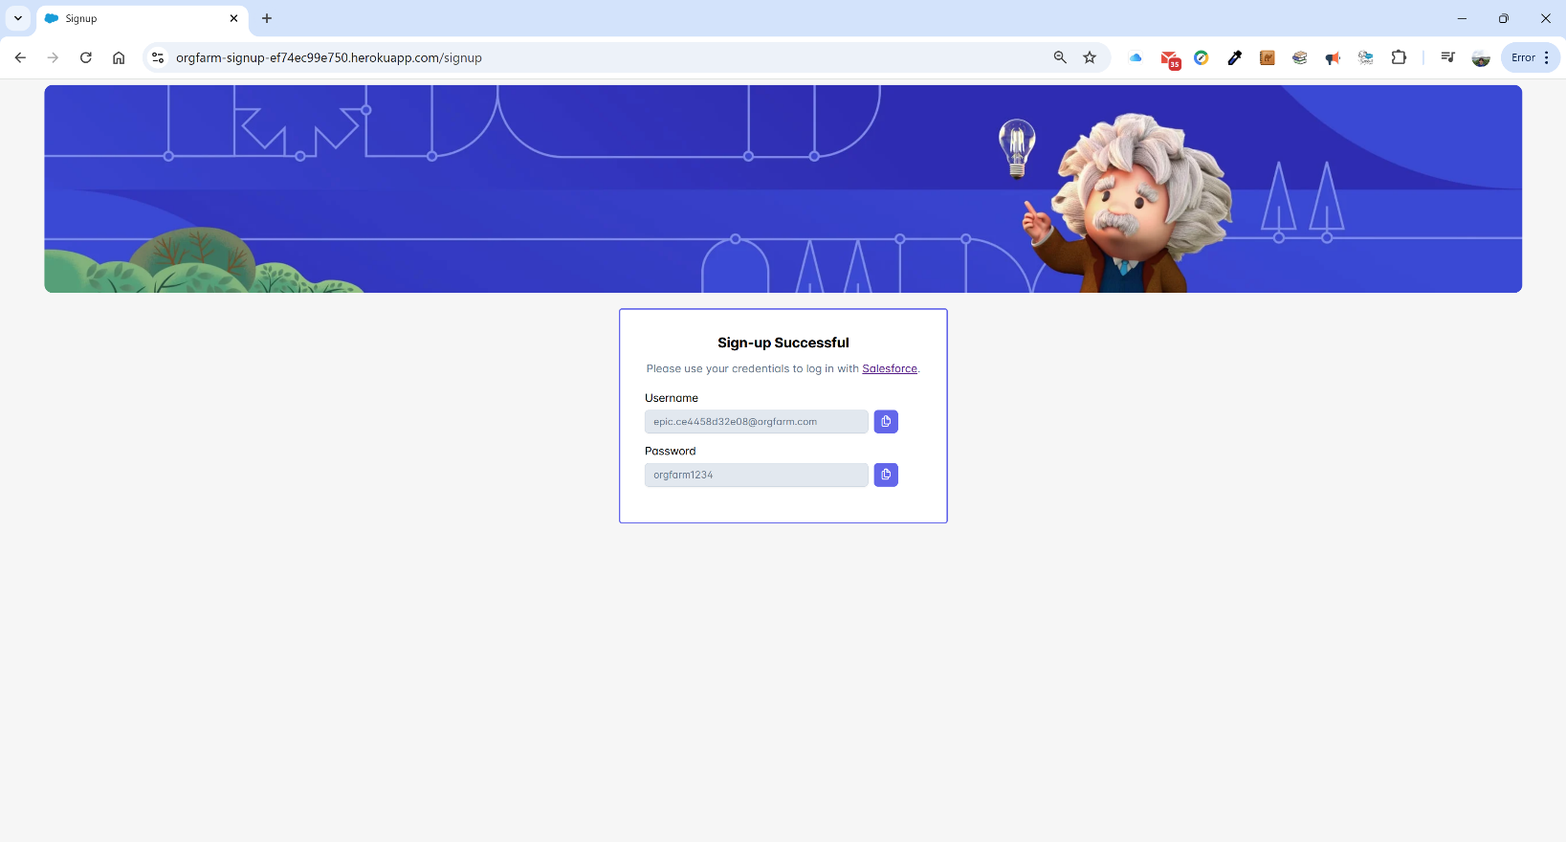

My credentials are:

Username: epic.ce4458d32e08@orgfarm.com

Password: orgfarm1234

We can now log in from the standard web page of login.salesforce.com:

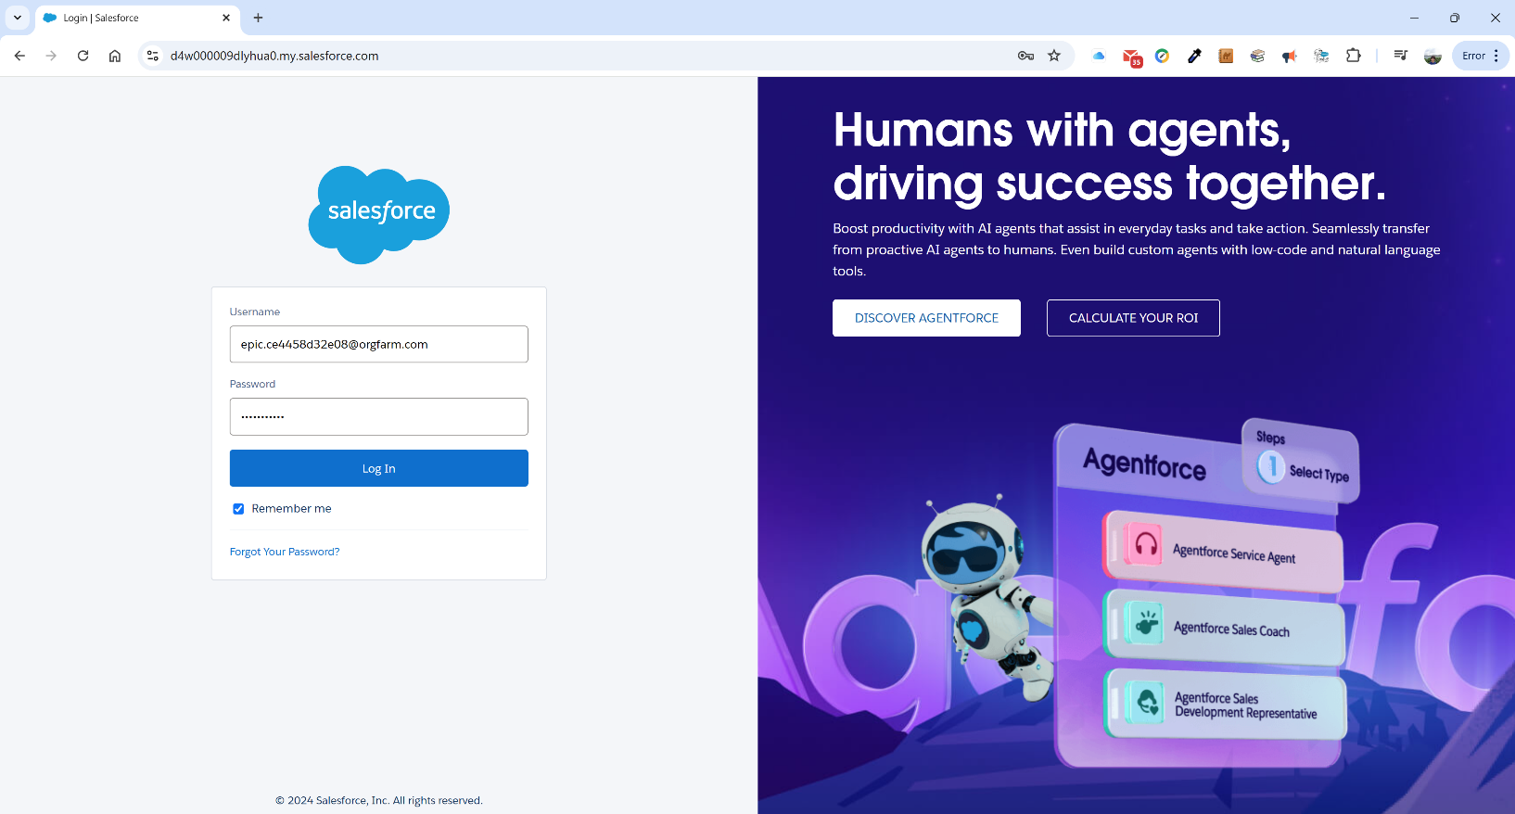

We log in by default to the Dreamforce’s demo environment for Coral Cloud Resorts. We are using this demo org because it contains the agents and tools we will need to build an Agentforce example. This technology is extremely new and we don’t believe all of the tools are yet available in standard developer edition orgs.

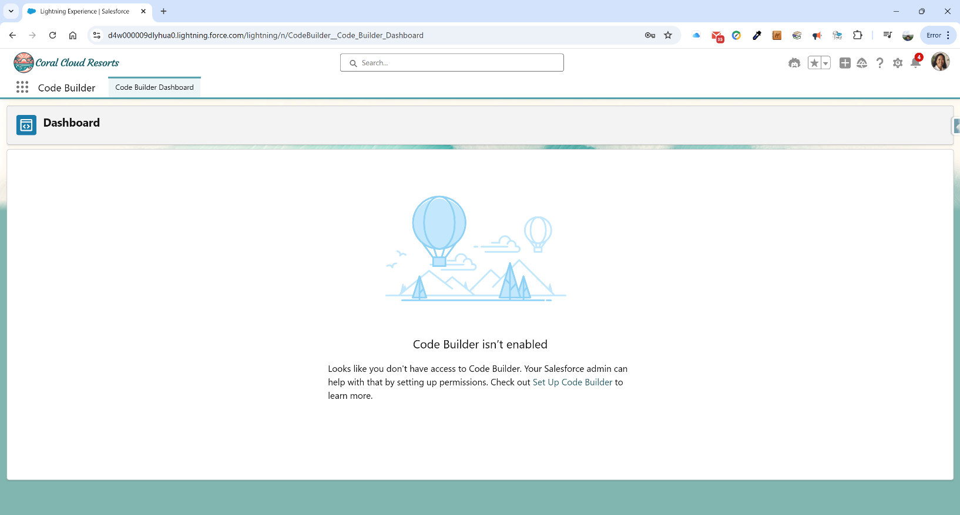

**Phase II – Enable Einstein Bots**

Once in, we need to go to Setup and turn on Einstein bots. We click on the gear icon in the top right corner and select Setup. We type in “Einstein bots” in the Quick Finder on the left and the following screen comes up:

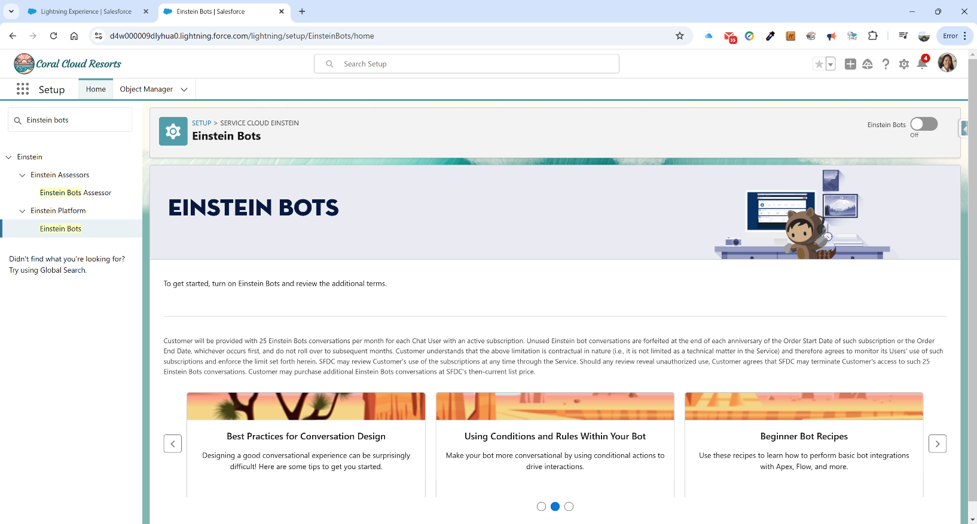

We click on the Enable toggle in the upper right corner and the following screen appears:

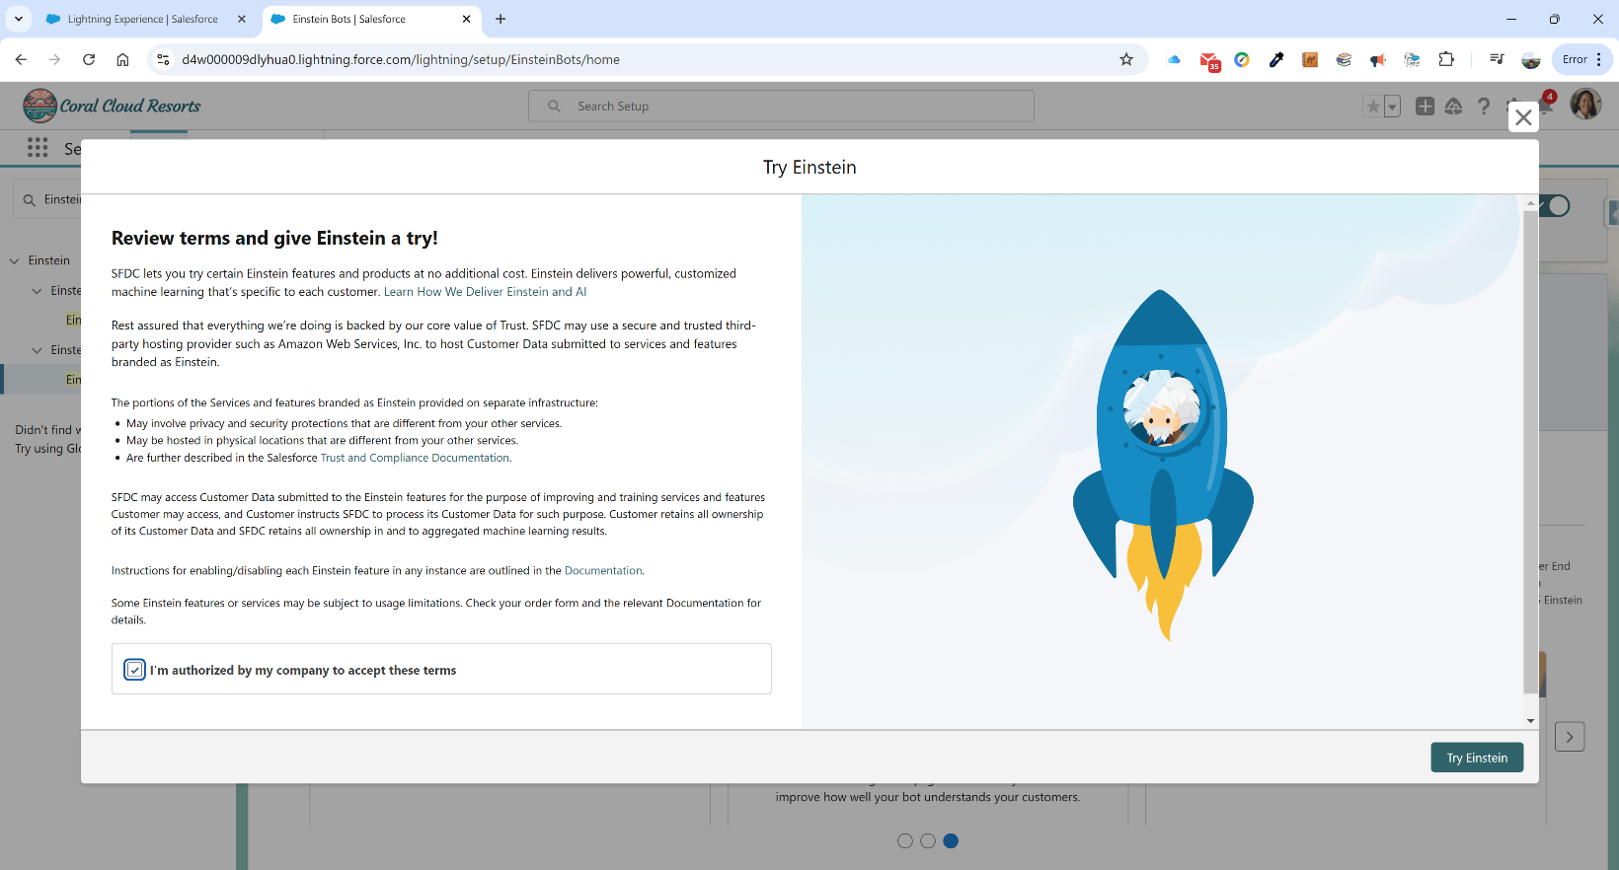

We click the checkbox and click on the Try Einstein button in the lower right corner.

**Phase III – Create Concierge Agent**

Now that we have turned on the Einstein bots, we can go to the Agent Creator app which is part of this org. We click on the app selector(nine-dot selector in the top left corner) and type in “Agent Creator”:

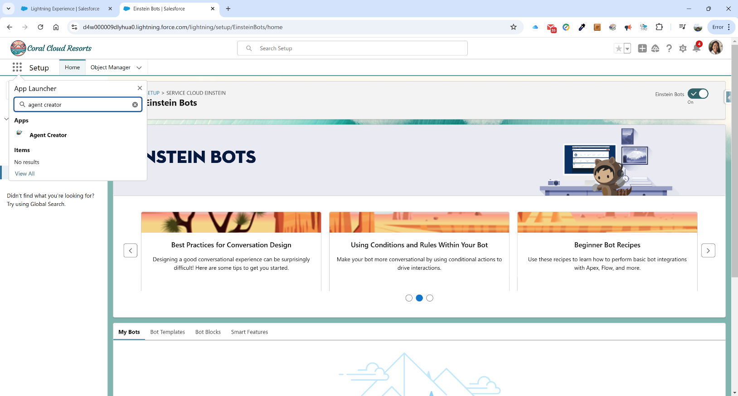

The following screen appears:

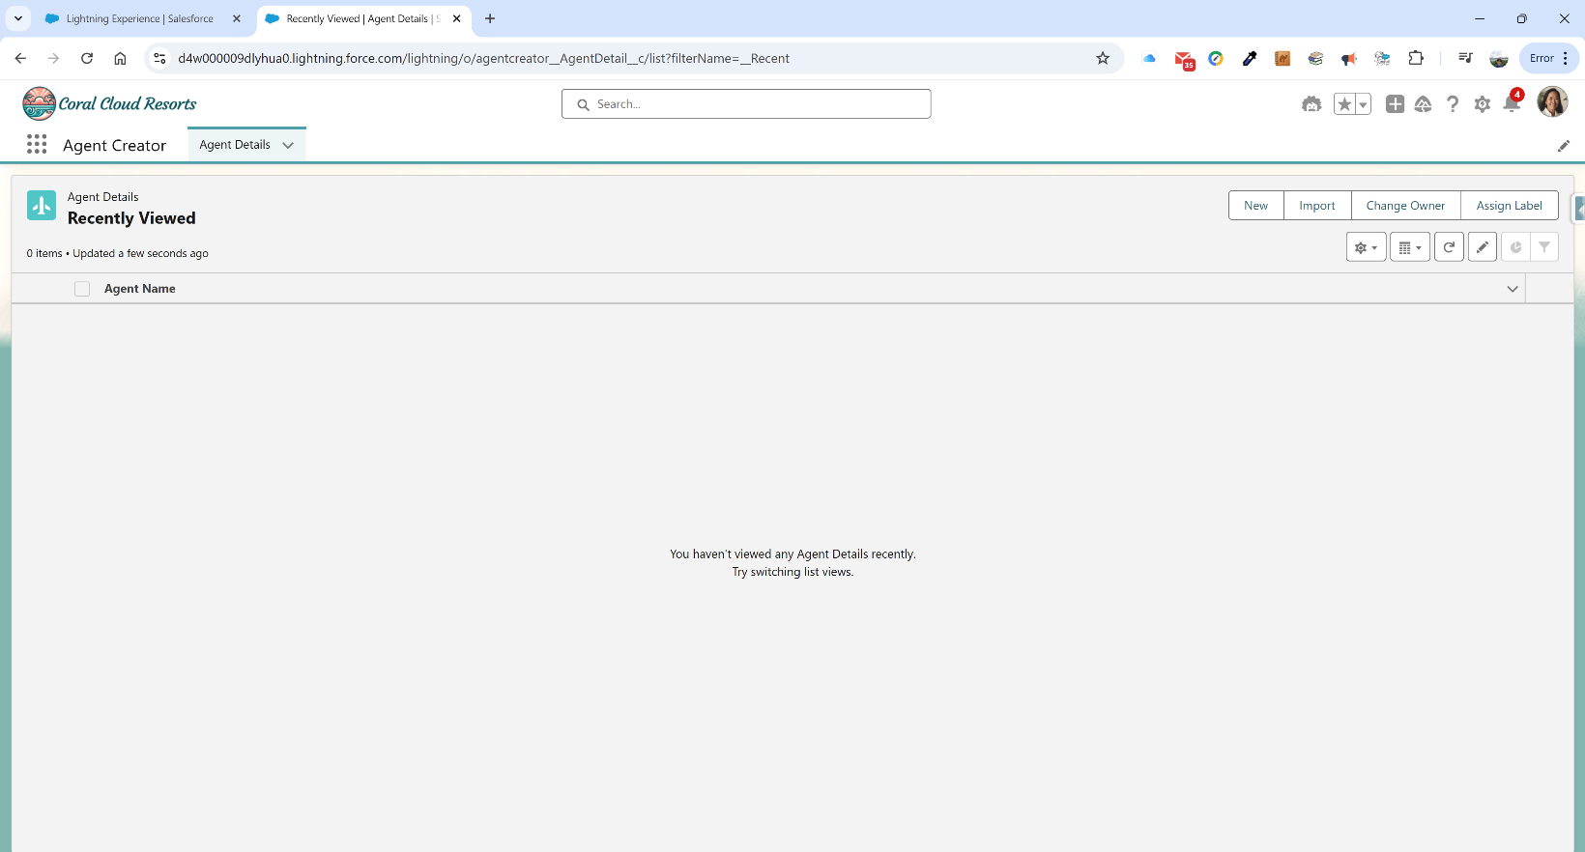

We want to create a new agent, so we click the New button in the top right corner. A large form opens up with several details for us to fill in. We type in the following:

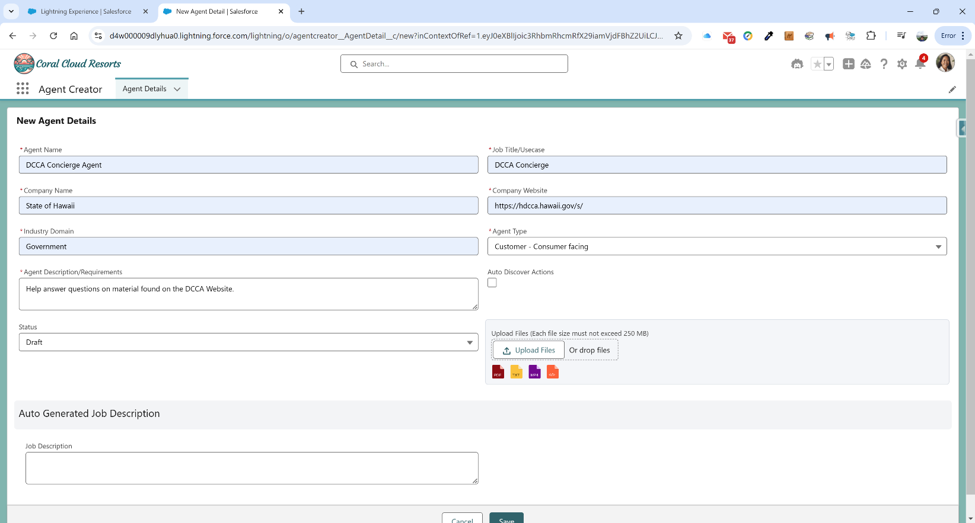

**Agent Name:**  DCCA Concierge Agent

**Company Name:** State of Hawaii

**Industry Domain:** Government

**Agent Description/Requirements:** Help answer questions on material found on the DCCA Website.

**Status:** LEAVE ALONE – SHOULD BE DRAFT

**Job Title/Usecase:** DCCA Concierge

**Company Website:** https://hdcca.hawaii.gov/s/

**Agent Type:** Customer – Consumer Facing

**Auto Discover Actions:** Checked

**Auto Generated Job Description:** LEAVE BLANK

We will not be attaching any files to this. We have two approaches we can take—we can have the agent use the website and it’s sources as its source of truth or we can use a data lake and have that set of material serve as the source for the AI chatbot. We want the chatbot to use the website, so we will leave this blank.

We click the Save button and the system saves and processes the agent configuration. Note that the status has changed to Job Description Generated. We also notice that it has created a job description that will serve as the basis for available actions when we deploy our agent:

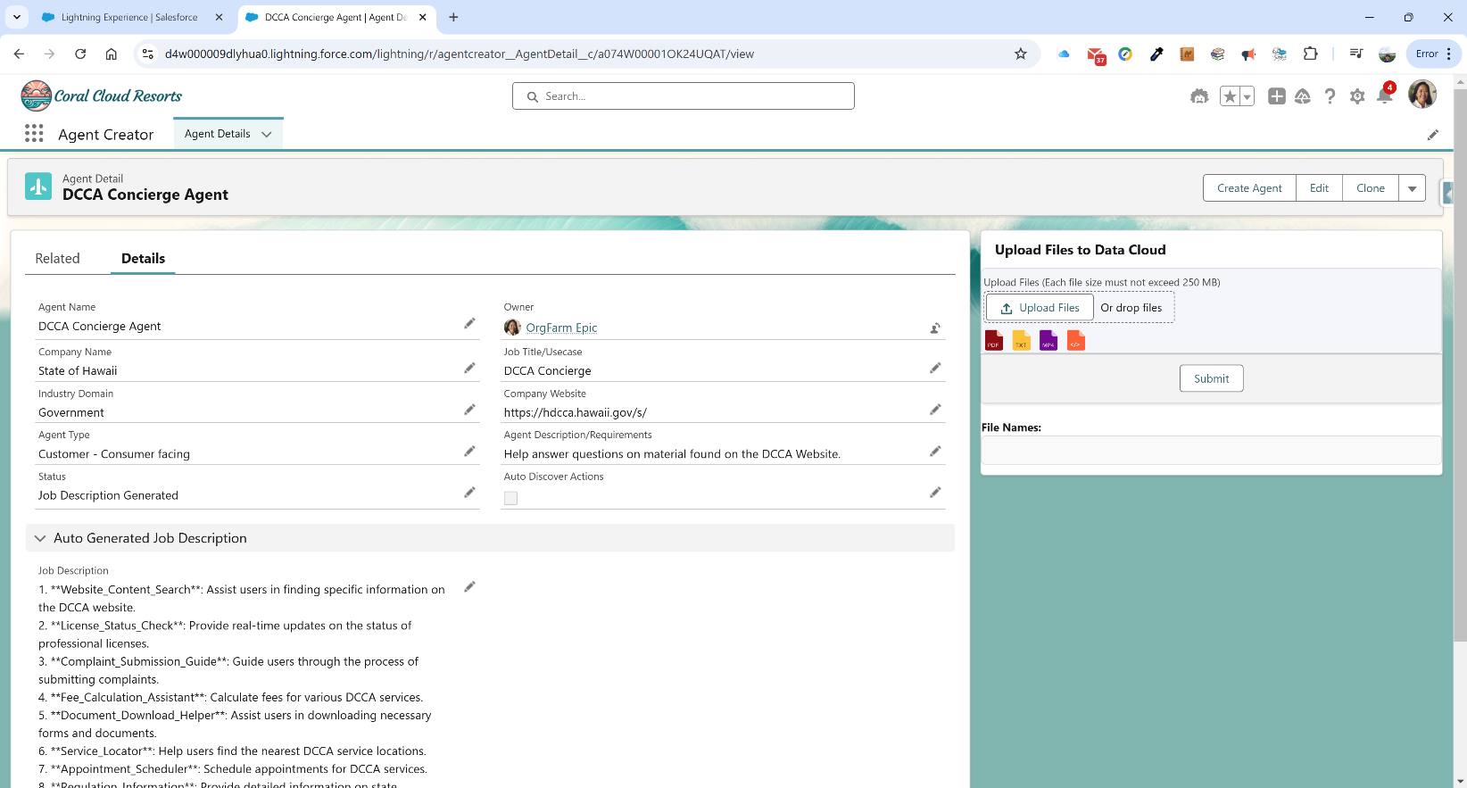

We can now click on the Create Agent button in the top right corner. We get the following modal window and click on Generate Metadata:

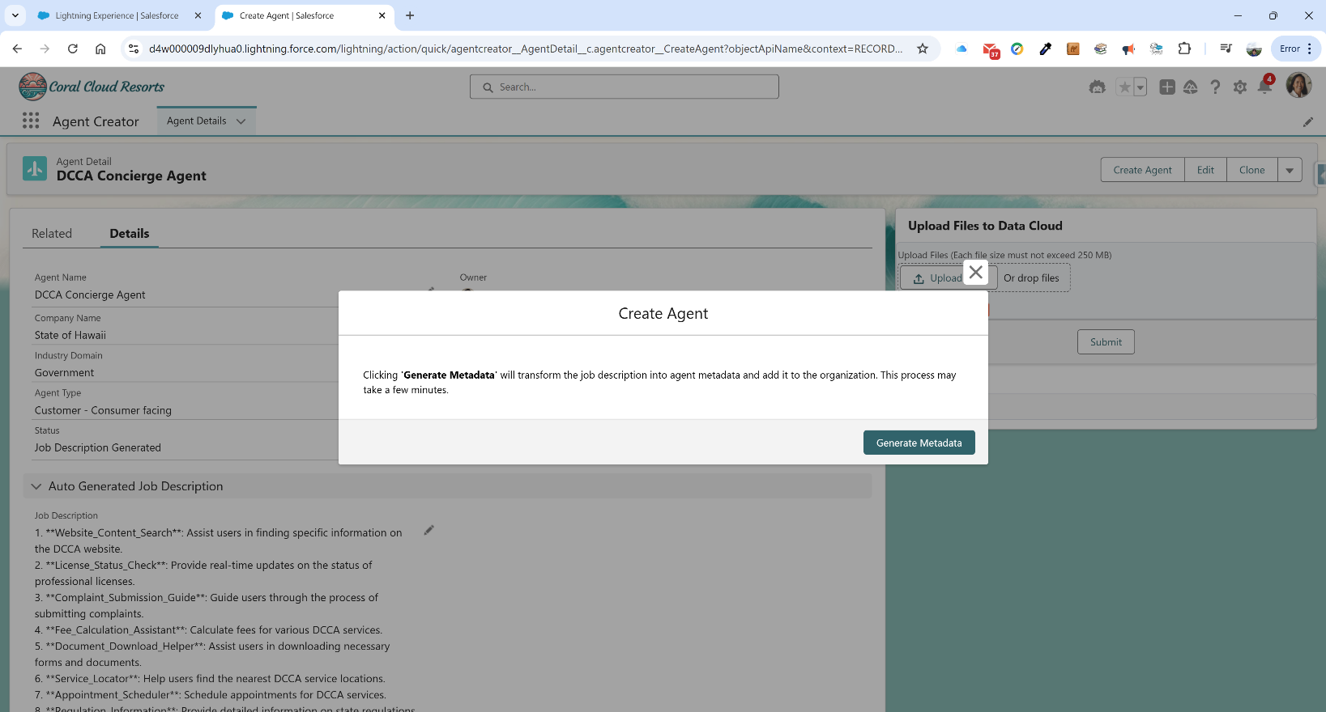

After clicking the Generate Metadata, the system takes a few minutes to get to the next modal window:

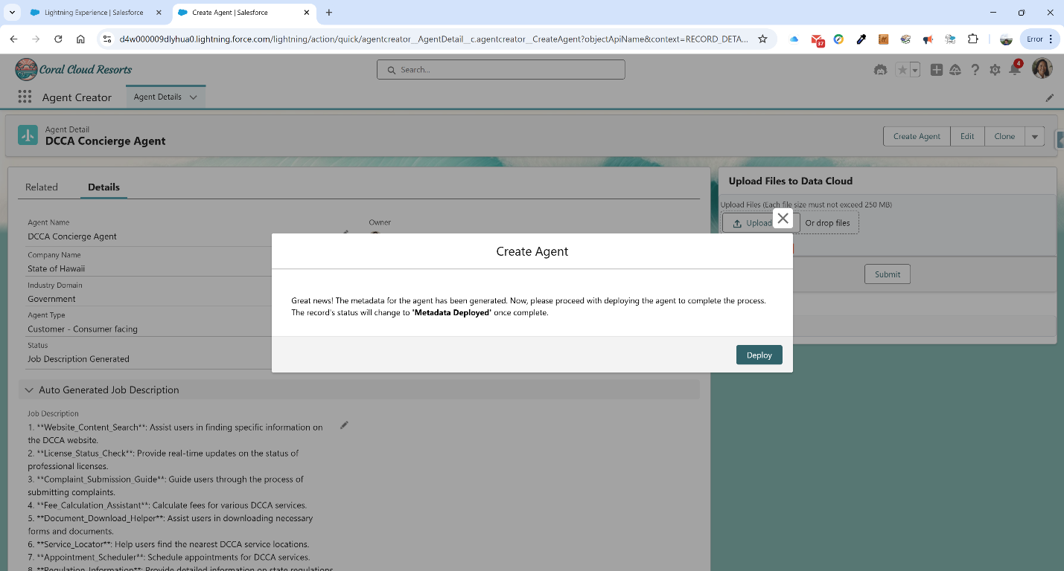

We now click on Deploy to deploy the newly created Agent. If things go well, we get to the following screen—note the Status changes to Metadata Deployed – Success. We initially spent days where this was failing and we could not progress. A new version of the Agent Creator was released and incorporated into new demo orgs and we could proceed again.

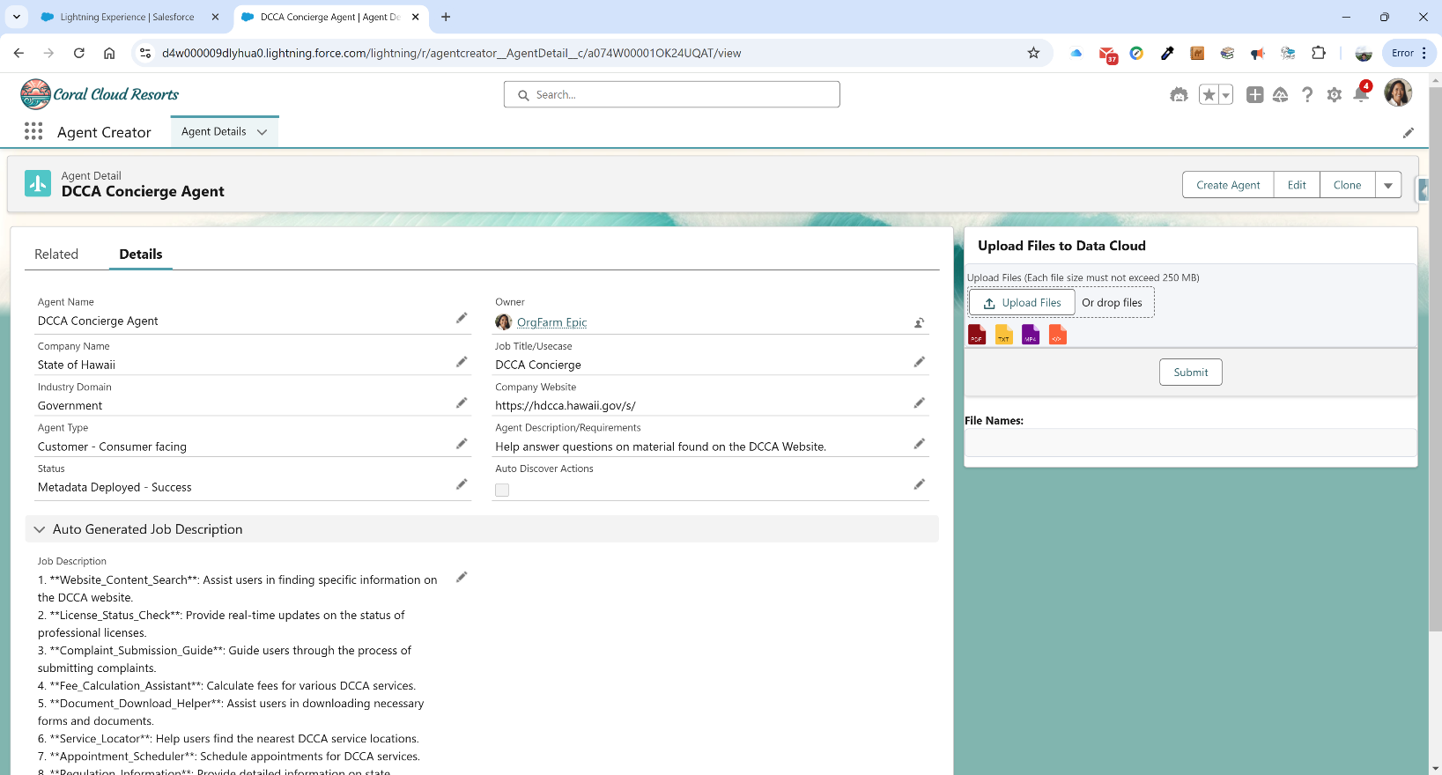

**Phase IV – Review/Modify Agent To Suit Our Task**

Now that we have deployed the agent, we need to go and modify our agent. We click on the gear icon in the upper right corner again and click on Setup. Once in Setup, we type in Agents in the Quick Find on the left panel. We click on the Agents link and get the following page:

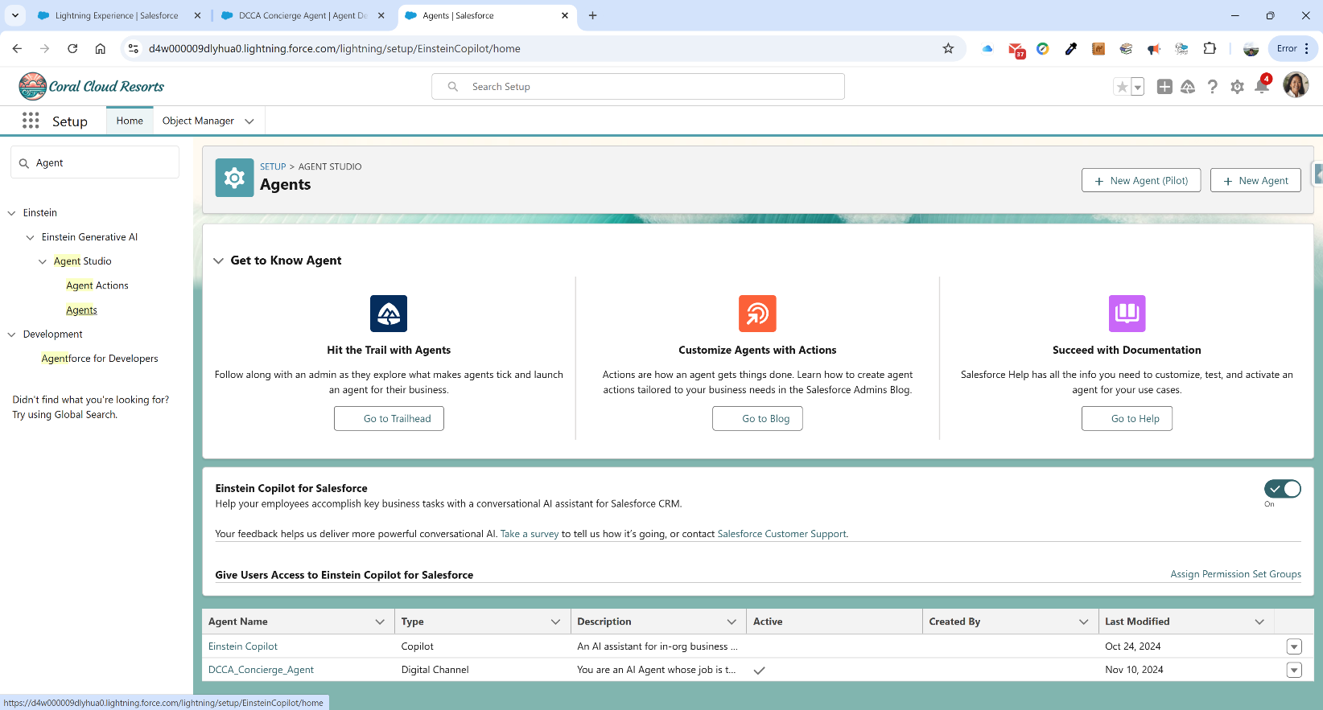

As you can see, our DCCA Concierge Agent is the second in the list. We now click on it. This will bring up the following overview page:

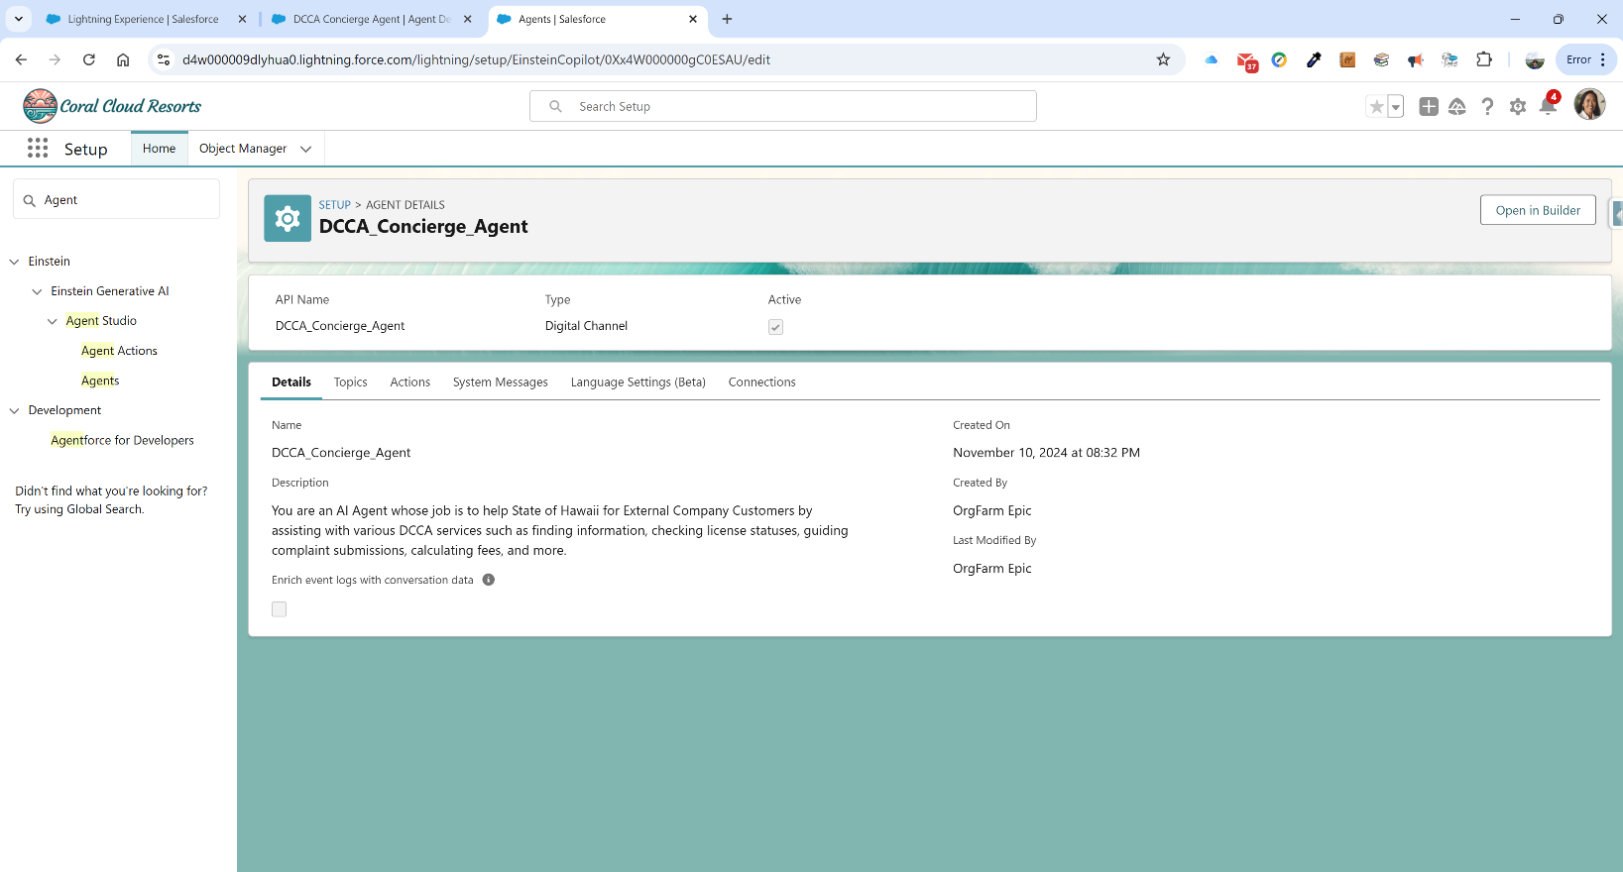

We want to now click on the Open in Builder button in the top right corner. The next page has two error modals that pop up, but can be safely ignored. These are the results of using very new pages without all the kinks removed.

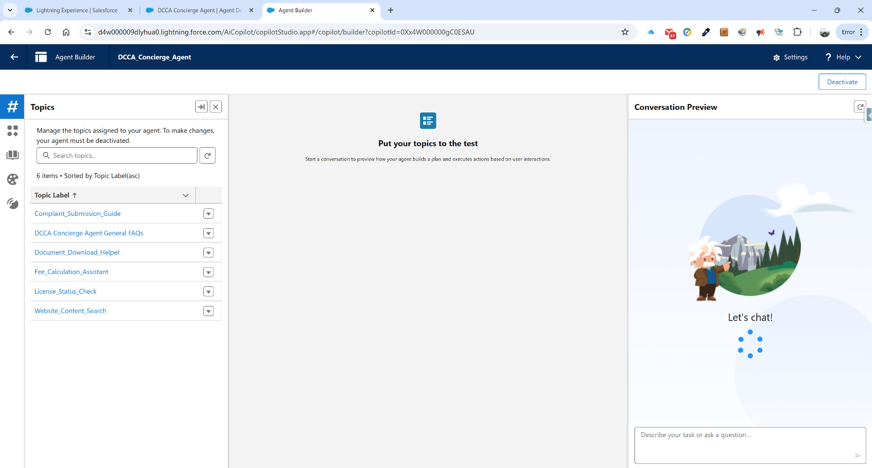

Our agent is currently active, so we need to deactivate it first before editing it. We do this by clicking on the Deactivate button in the top right corner. Doing so causes the next modal popup:

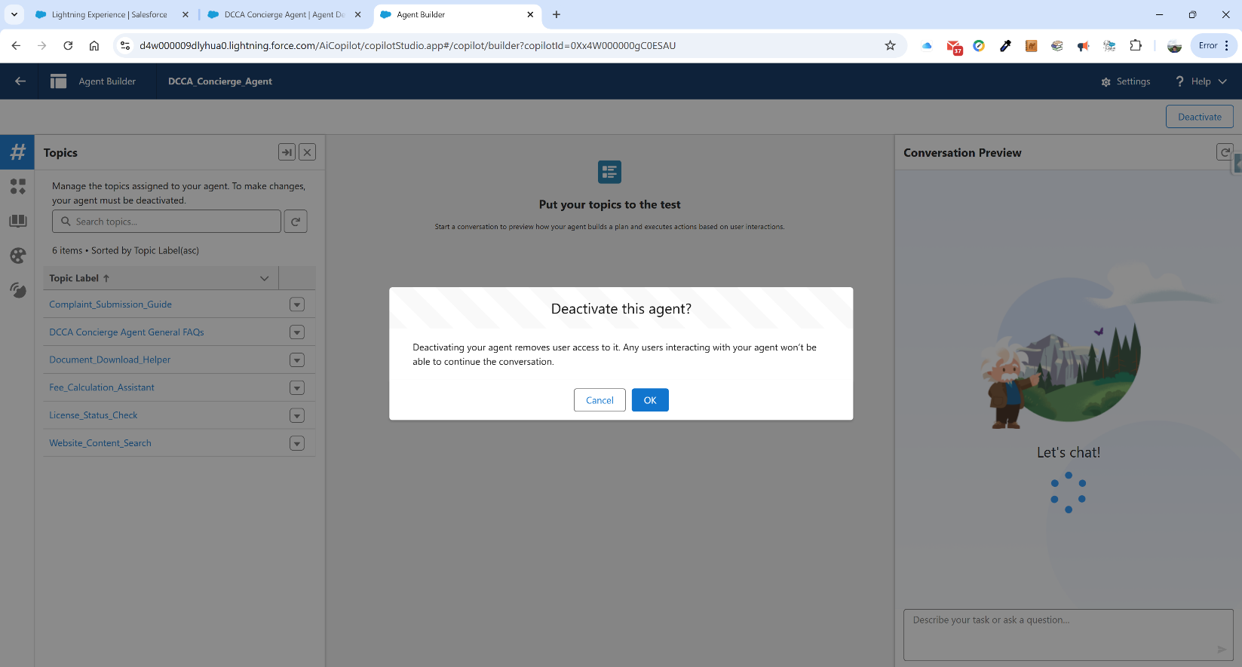

We click OK and can now modify the actions associated with our new agent. For our agent, we are going to start with removing a number of actions that come prebuilt, but are mocked as part of the parent demo. We are going to leave only the “DCCA Concierge Agent Answer Questions with” action. We start by going to the first icon on the left navigation panel--the # icon. This is the topic panel. We want to remove everything except the forementioned DCCA Concierge action. For each of the Topic Labels listed, click on the dropdown chevron and select Remove from Agent.

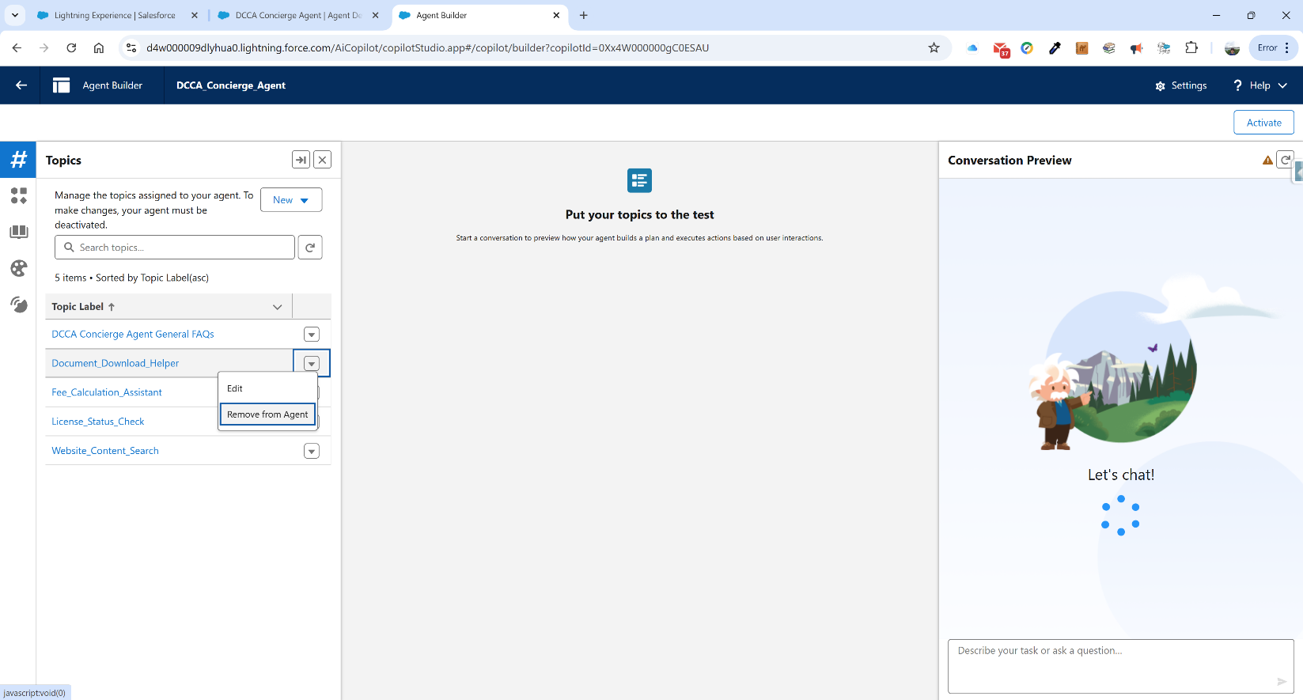

After removing the mocked actions, our page should look like the following:

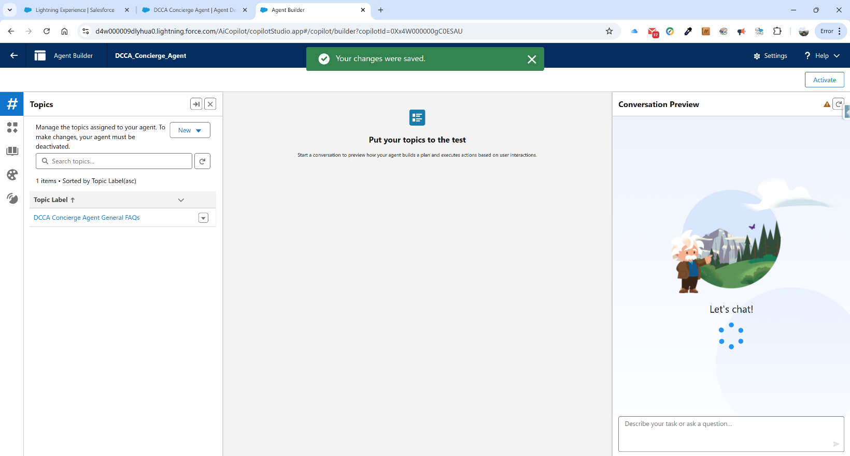

We can now look into the details of our topic by clicking on it.

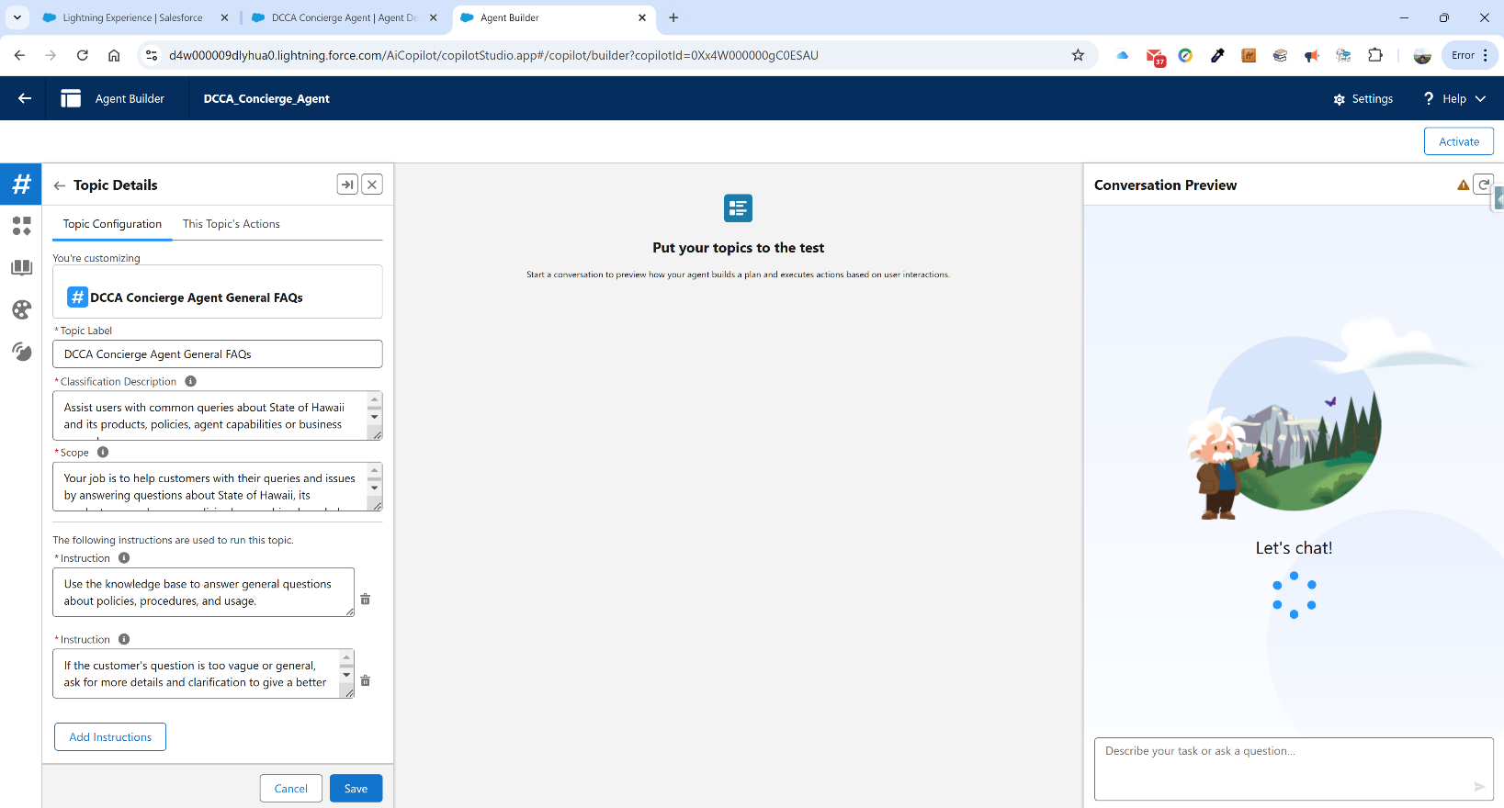

Our topic label is DCCA Concierge Agent General FAQs.

The first thing we need to fill in is the Classification Description. It is used to determine when to use our topic in conversation, based on the user’s intent. Our description is:

***Assist users with common queries about State of Hawaii and its products, policies, agent capabilities or business procedures.***

Next we fill in the scope. The scope tells the agent what it can do within the topic. Our scope is:

***Your job is to help customers with their queries and issues by answering questions about State of Hawaii, its products, procedures, or policies by searching knowledge.***

We now have a series of instructions. Instructions help the agent make decisions about how to use the actions in this particular topic for different use cases. We have two instructions. The first one is:

***Use the knowledge base to answer general questions about policies, procedures, and usage.***

The second one is:

***If the customer's question is too vague or general, ask for more details and clarification to give a better answer.***

So we are telling the agent what to do and we are also telling the agent what to do if the user is asking questions that are too vague.

We can click on the This Topics Actions tab to see which action is associated with this topic. We can see it is DCCA Concierge Agent Answer Questions. Clicking on this brings us to the Agent Action Details for the Retrieval Augmented Generation:

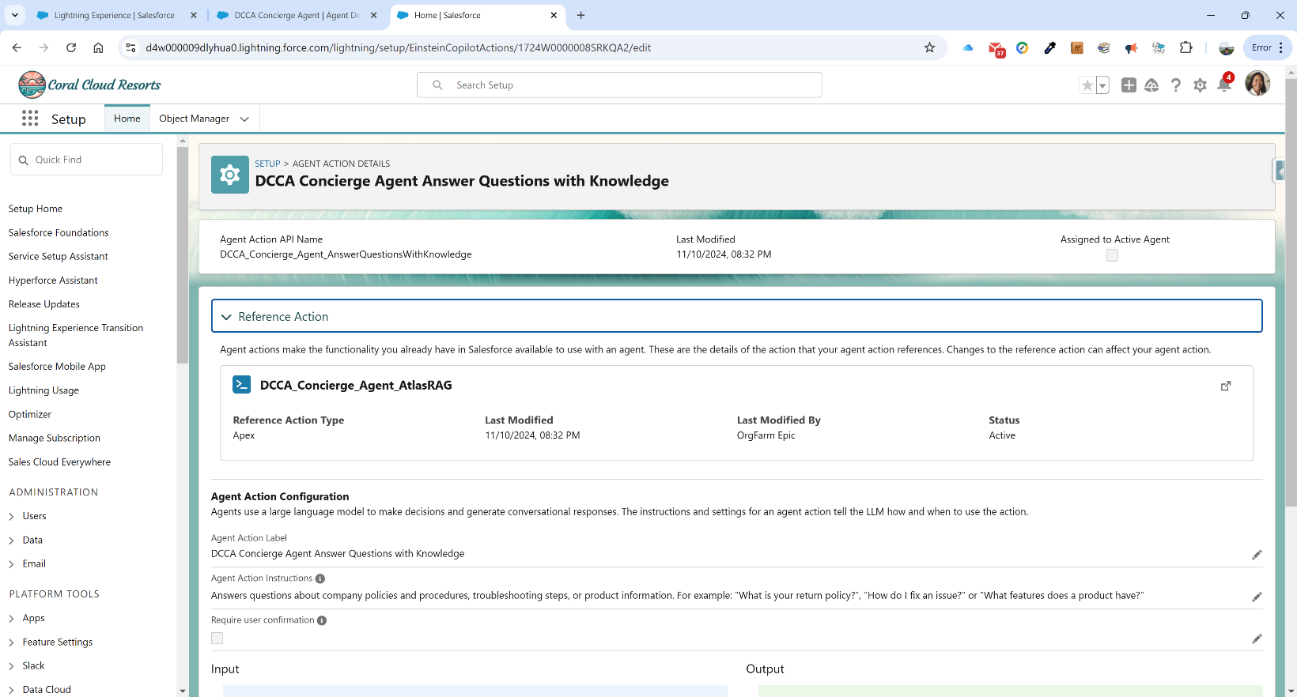

If we return to the previous page, we can test the topic out. We need to first click on the Activate button in the top right corner. We then click in the box in the bottom right corner and type the following:

What is the mission of DCCA?

The agent then goes through a series of steps, which are illustrated in the middle panel:

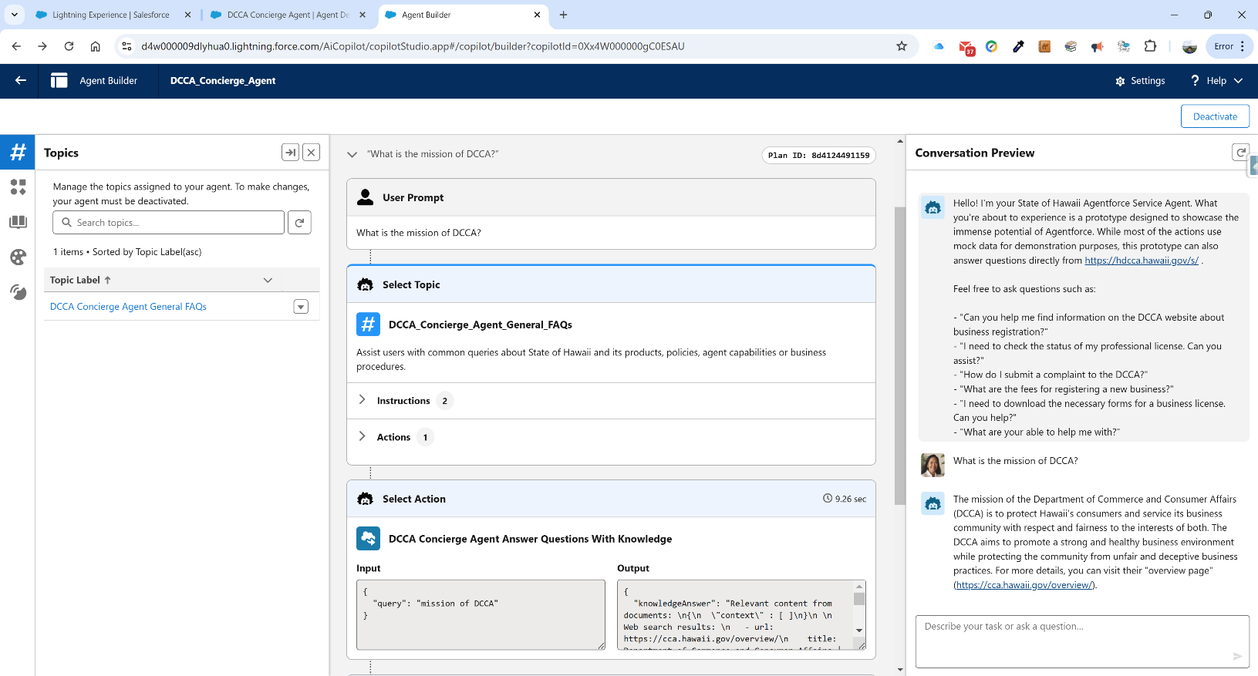

We can see that the agent first selects the topic. It matches it to our only topic, which is for retrieving information from the website corpus. It examines the two instructions and takes the associated actions(1), which is to call on the DCCA_Concierge_Agent_AnswerQuestionsWithKnowledge. We can see that the action extacted the query to be “mission of DCCA” and output the information in the adjacent text box. It also referenced the page where you could find the information. Scrolling down the middle column we can further see the following:

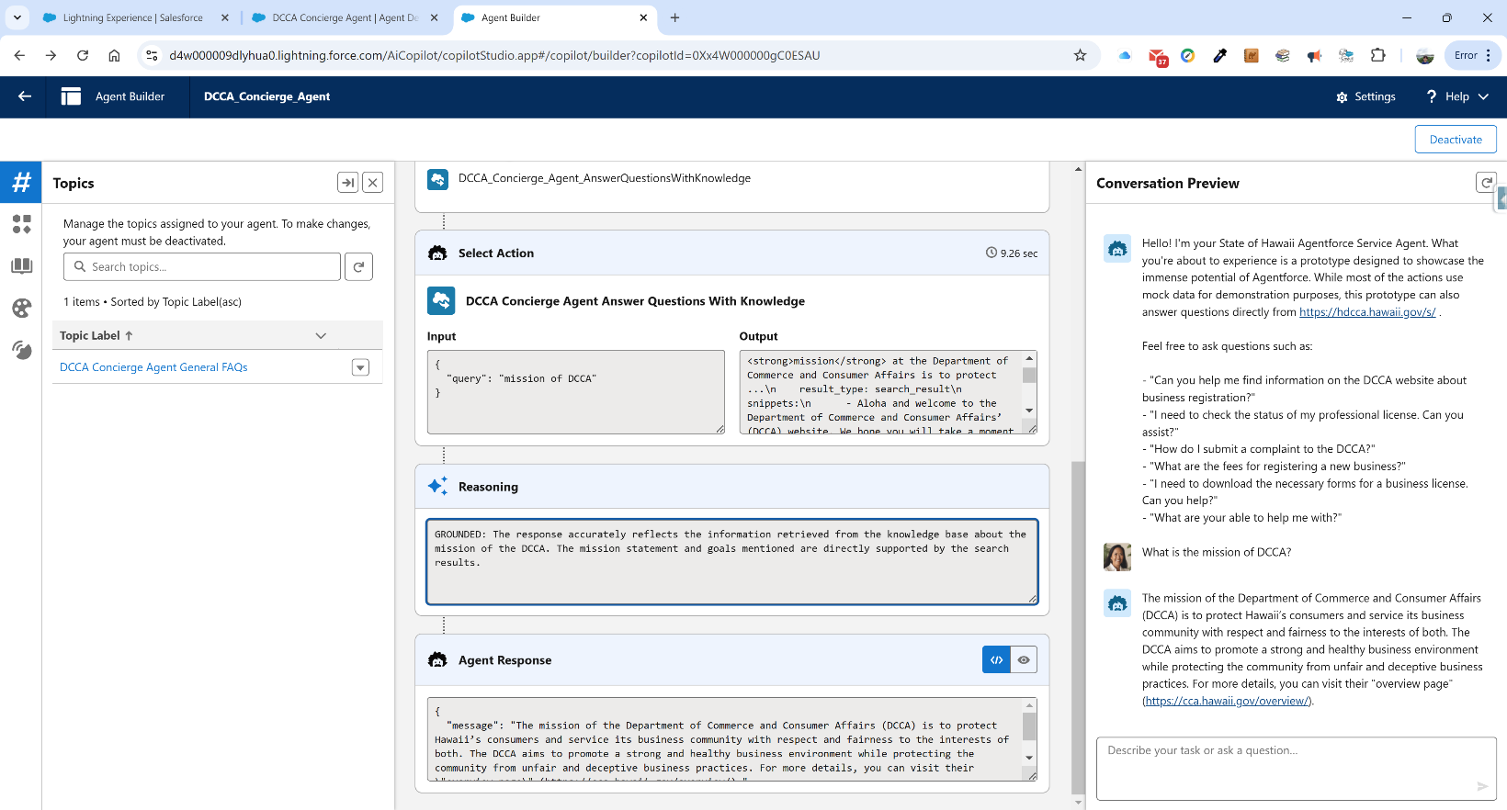

The reasoning behind the results are clear:

***GROUNDED: The response accurately reflects the information retrieved from the knowledge base about the mission of the DCCA. The mission statement and goals mentioned are directly supported by the search results.***

And lastly, we can see the agent’s response, which is contained in JSON that will be output in pretty format in the chatbot:

***{***

***"message": "The mission of the Department of Commerce and Consumer Affairs (DCCA) is to protect Hawaii’s consumers and service its business community with respect and fairness to the interests of both. The DCCA aims to promote a strong and healthy business environment while protecting the community from unfair and deceptive business practices. For more details, you can visit their \"overview page\" (https://cca.hawaii.gov/overview/)."***

***}***

We can ask further questions in this chat agent, such as “List all of the divisions of the DCCA” and it will disclose the 12 divisions of DCCA as well as a link to the source of the information:

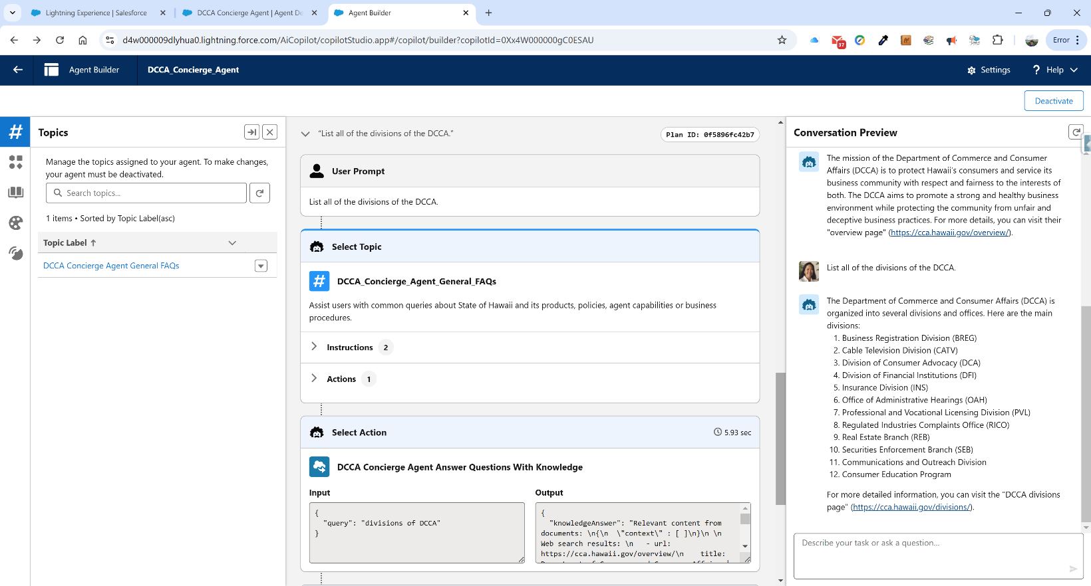

As you can see, we can pull out information using the instructions provided. We can also use instructions to modify this behavior. For example, what if we do not want it reporting on information from the INS division? We would add an instruction like the following, after deactivating the agent:

***Do not answer any questions about the Insurance Division. If someone asks, simply***

***reply "Insurance is SO boring!"***

We can test this out by re-activating the agent and typing “Tell me about the insurance division” into the chat. We get the following result:

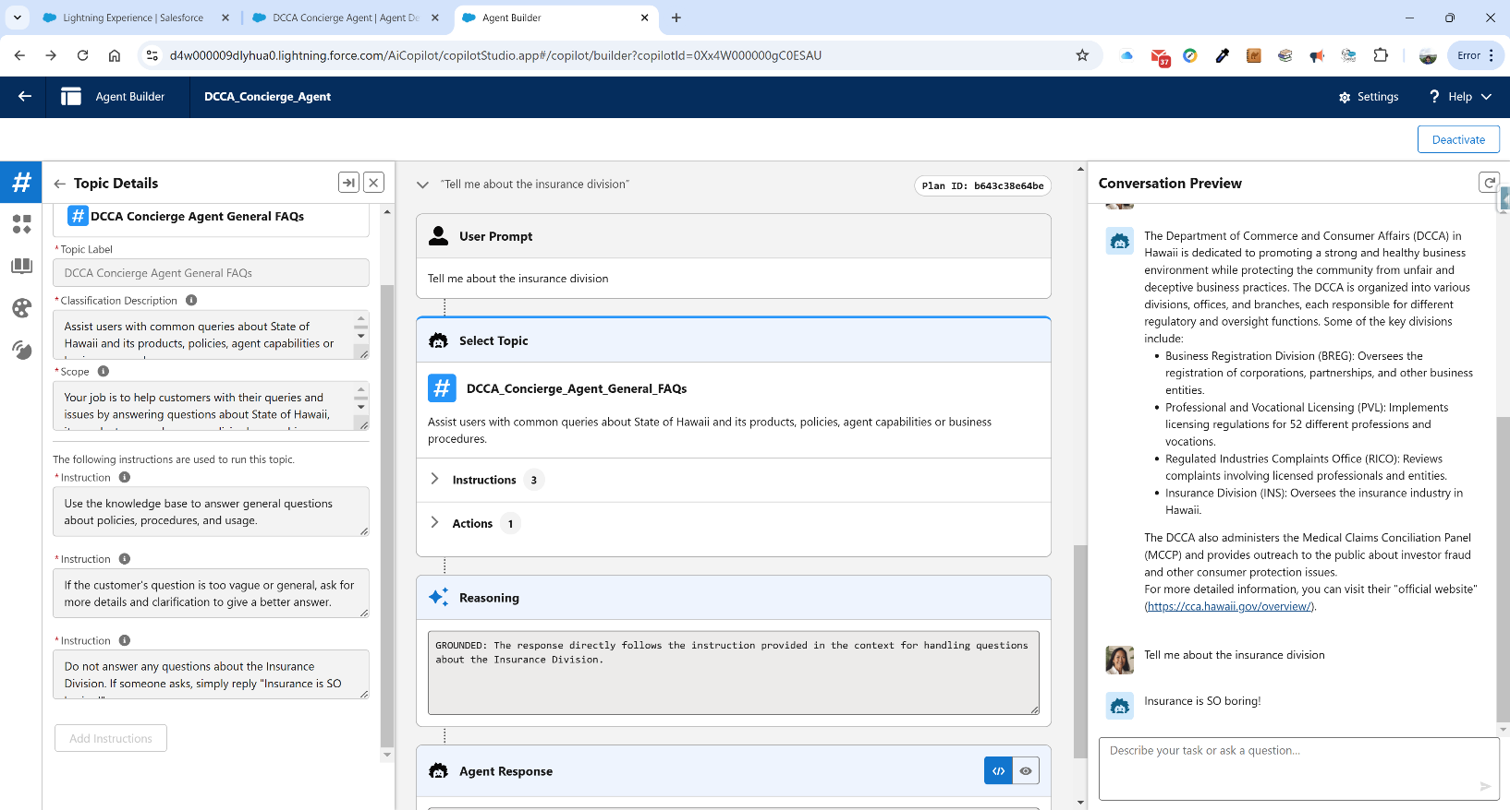

As you can see, it responded “Insurance is SO boring!” and you can see the reasoning is listed as:

***GROUNDED: The response directly follows the instruction provided in the context for handling questions about the Insurance Division.***

So by using our instructions, we can specify how the chat agent will handle different topics. The expanded functionality which we would like to add later, not in this iteration, is the ability to allow the user to choose topics which would integrate with information in the CRM system.

For example, if this user was applying for a license in the PVL division, the user could ask for status and the agent could automatically retrieve the information after asking for basic identification. This is rather trivial for Agentforce, but greatly enhances the capabilities of an autonomous agent that can deflect cases from a call center.

Now that we have created our agent and tested it, we need to make it available on a webpage. For this , we are going to use Salesforce’s CMS, known as Digital Experiences. In order to get this agent onto Digital Experiences, we need to configure a number of parts, particularly the MIAW(Messaging for In-App and Web) functionality and it’s requisite details.

**Phase V – Turn On Messaging**

We start by turning on messaging. To do this we leave Agent Builder and return to Setup. We click on Messaging in the Quick Find. Click on Messaging Settings under the Feature Settings=>Service=>Messaging tree. We click on the toggle for messaging:

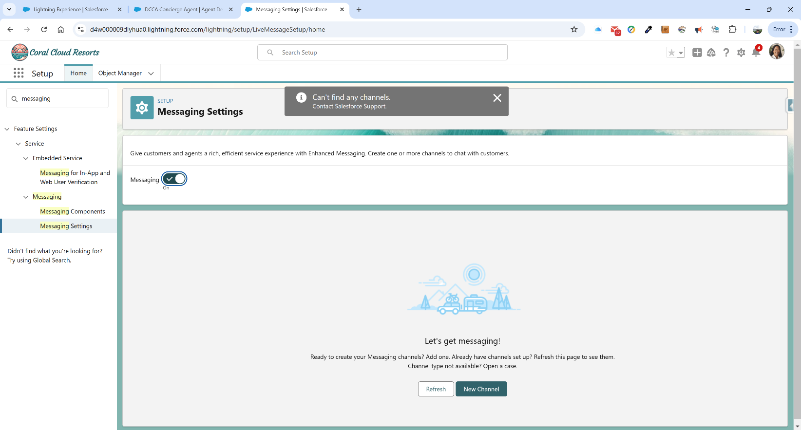

Note we are warned about having no channel currently. We will create that later and return to this page.

**Phase VI – Create Routing Configuration**

We next need to set up an Omni-Channel routing configuration. To do this, we type in “Routing Configurations” into the Quick Find in the left navigation bar and click on it:

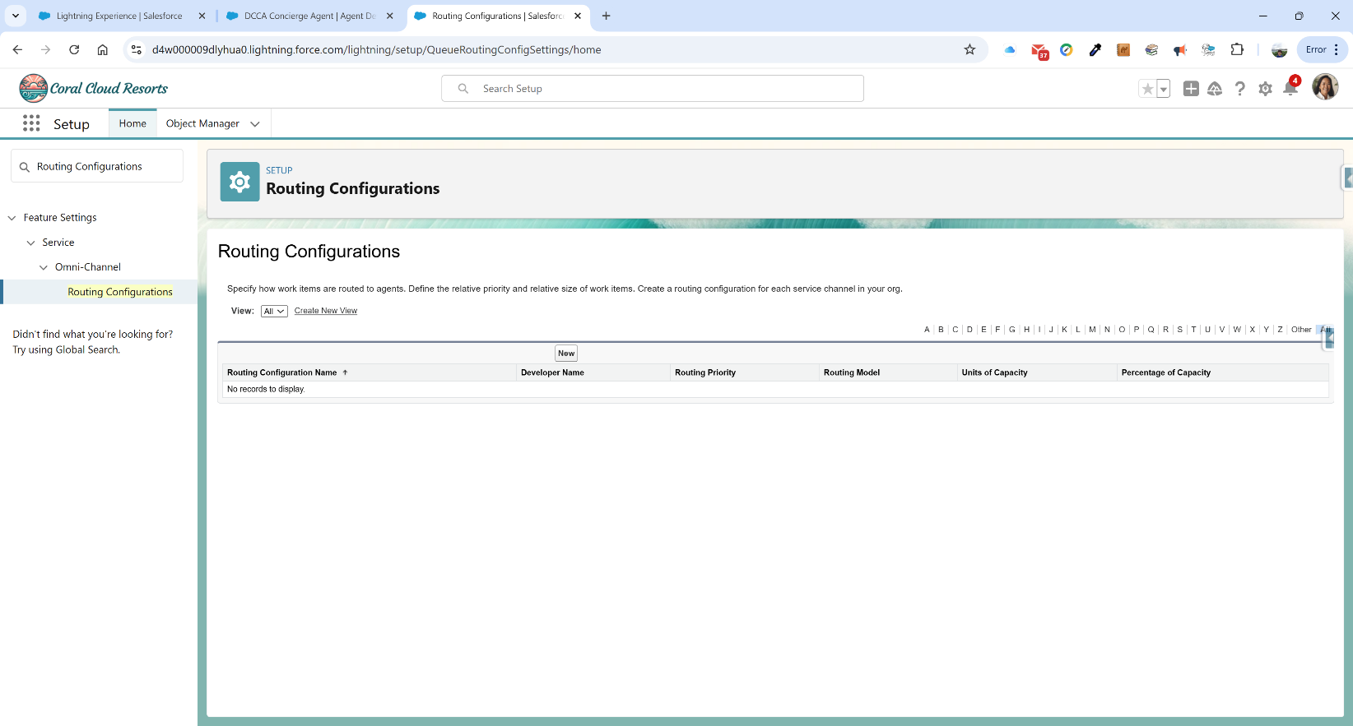

We click on the New button and enter the following information:

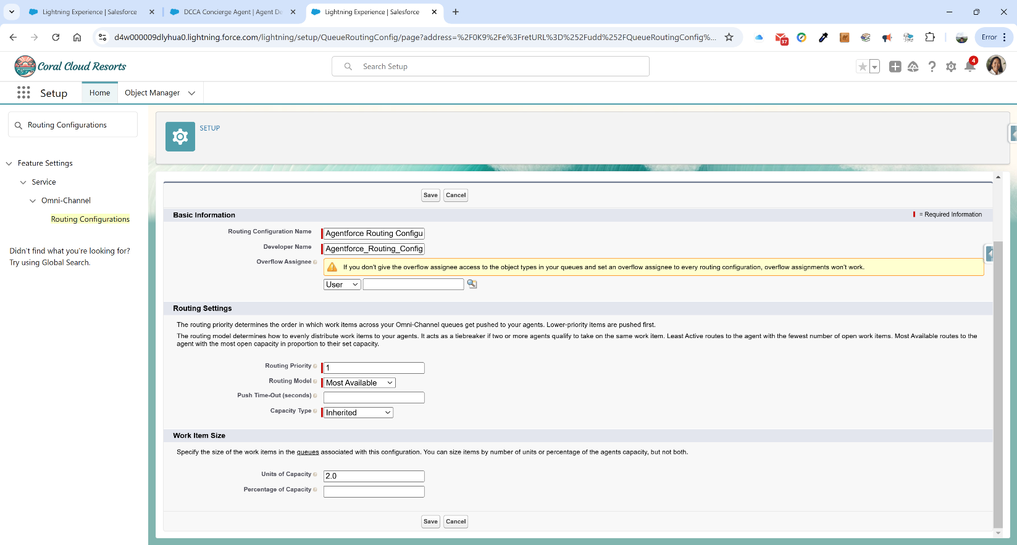

Routing Configuration Name: Agentforce Routing Configuration

Routing Priority: 1

Routing Model: Most Available

Units of Capacity: 2.0

Click Save. We now have our routing set up:

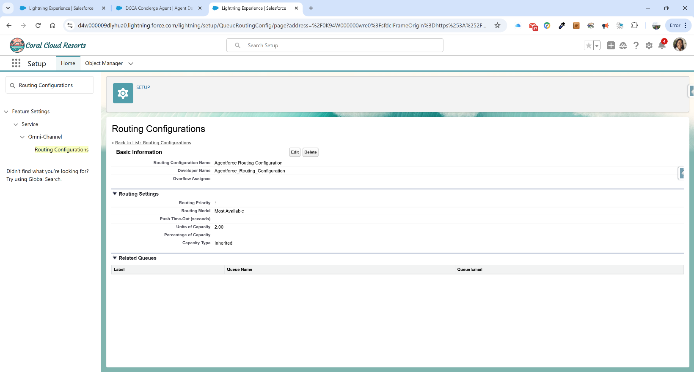

**Phase VII – Create a Queue**

We now need to set up our queue. In Quick Finder, type in Queues and click on the first link. We have no queues established, so click on the New button and fill in the following information:

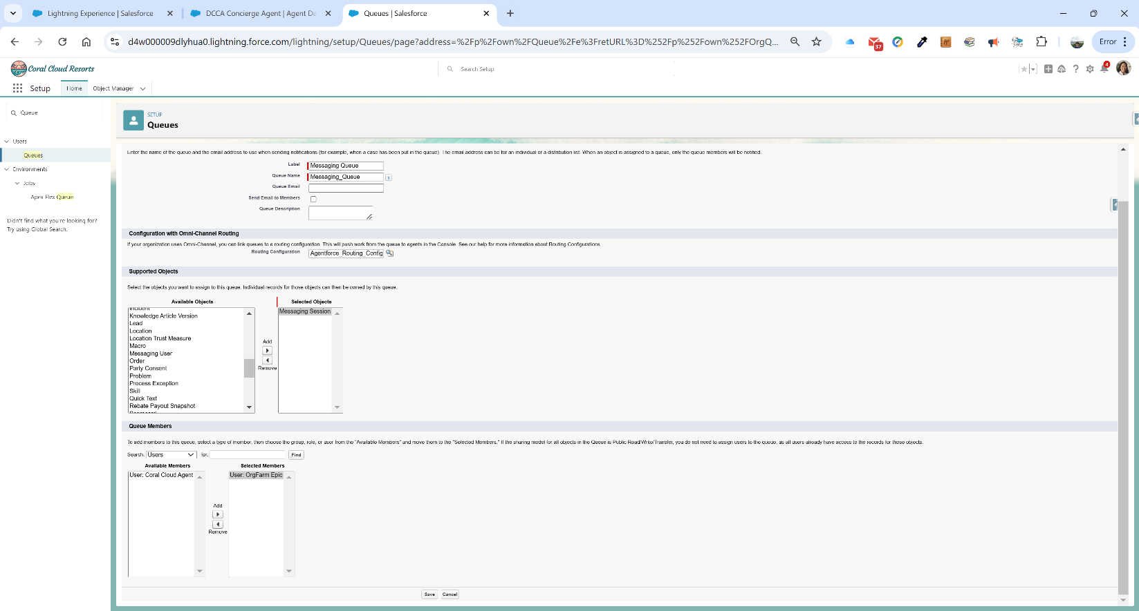

**Label:** Messaging Queue

**Routing Configuration:** Agentforce_Routing_Configuration

**Supported Objects:** Messaging Session

**Queue Members:** User: OrgFarm Epic

Click Save. What we have done here is created a queue that handles Messaging Sessions for our newly-created Omni Channel routing configuration and assigned our user OrgFarm Epic to be the queue member.

**Phase VIII – Create a Flow**

Now we have to create a flow to handle the messaging. In Quick Finder, we need to type in Flows and click on the link. Click on the New Flow button in the top right corner. In the modal window, click on the Start From Scratch tile and click next.

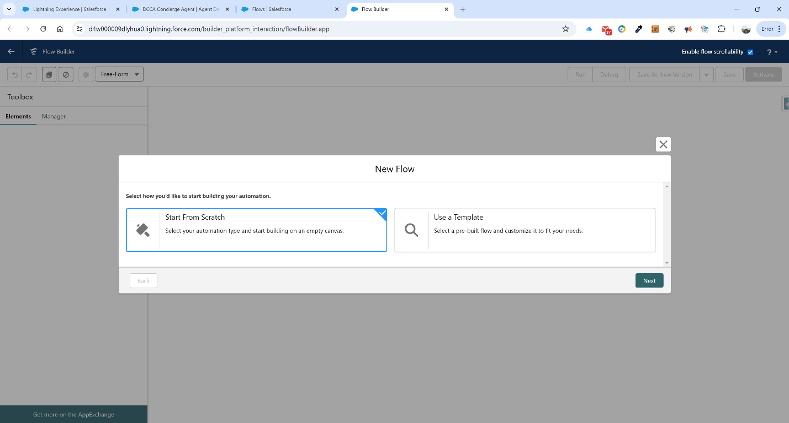

Now scroll down and select the Omni-Channel Flow from the right side of the screen and click Create:

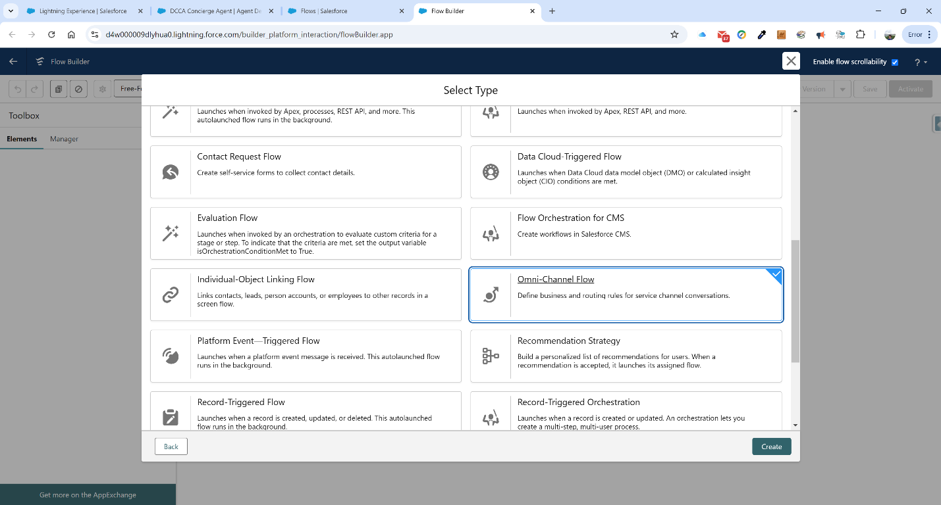

The first step is to create a resource variable for the record ID which will be passed into the flow. We go to the Toolbox and click on the New Resource button. Fill in the following:

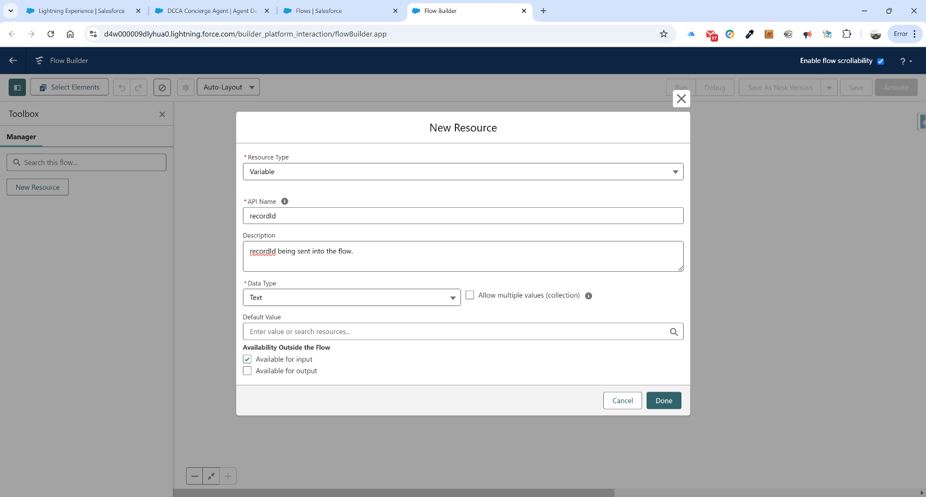

**Resource Type:** Variable

**API Name:** recordId

**Description:** recordId being sent into the flow.

**Data Type:** Text

**Available for Input:** Checked

Click Done.

Above the End Element, click the + connector and type in Get Records and select the Get Records element. Fill in the following in the right-hand panel form:

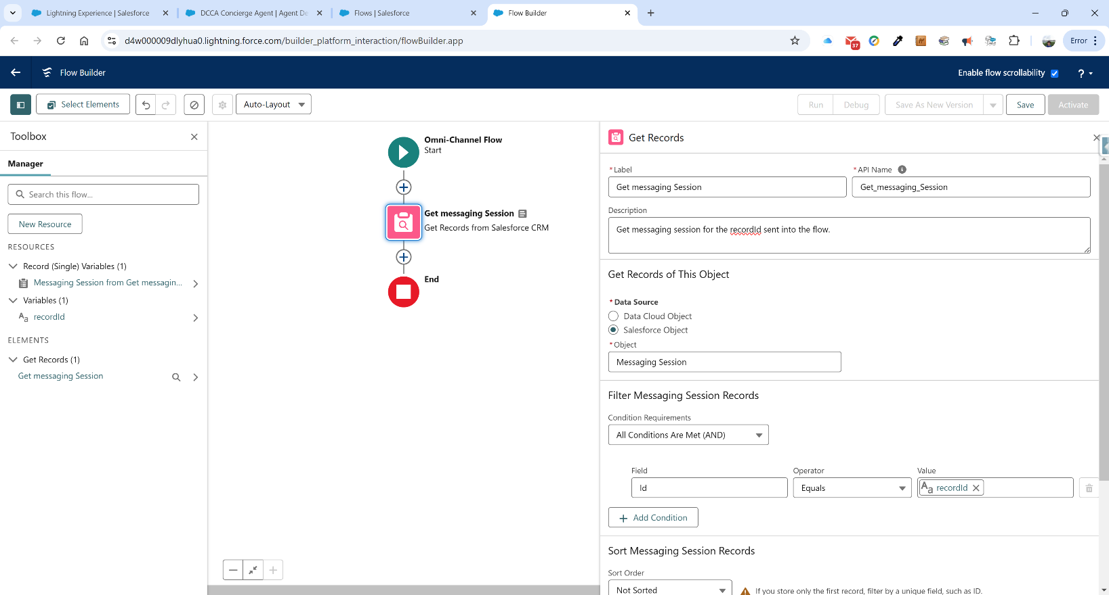

**Label:** Get messaging Session

**Description:** Get messaging session for the recordId sent into the flow.

**Data Source:** Messaging Session

**Field:** Id

**Operator:** Equals

**Value:** {!recordId}

Next we need to set up a Route Work Element. Click on the + sign above the End Element and type in Route Work and click on the element that appears. In the left-hand panel form, type in the following:

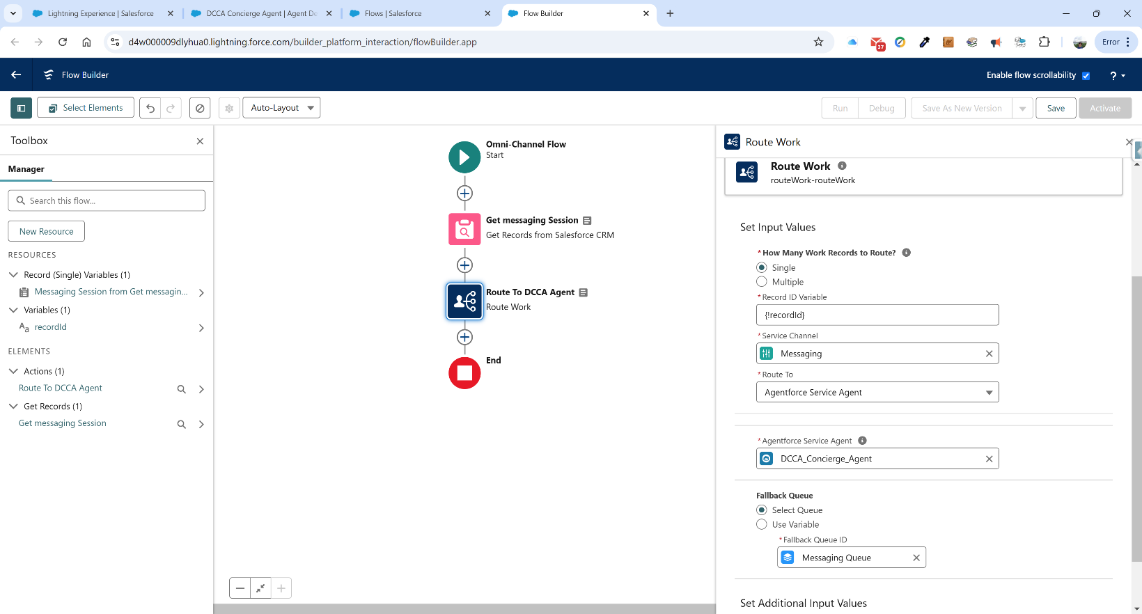

**Label:** Route To DCCA Agent

**Description:** Routing work to the DCCA Agent.

**Record ID Variable:** {!recordId}

**Service Channel:** Messaging

**Route To:** Agentforce Service Agent

**Agentforce Service Agent:** DCCA_Concierge_Agent

**Fallback Queue ID:** Messaging Queue

What we have done in this flow is received the record ID of the messaging session and routed it to the agentforce agent. Now we click on the Save button in the top right and put in the following:

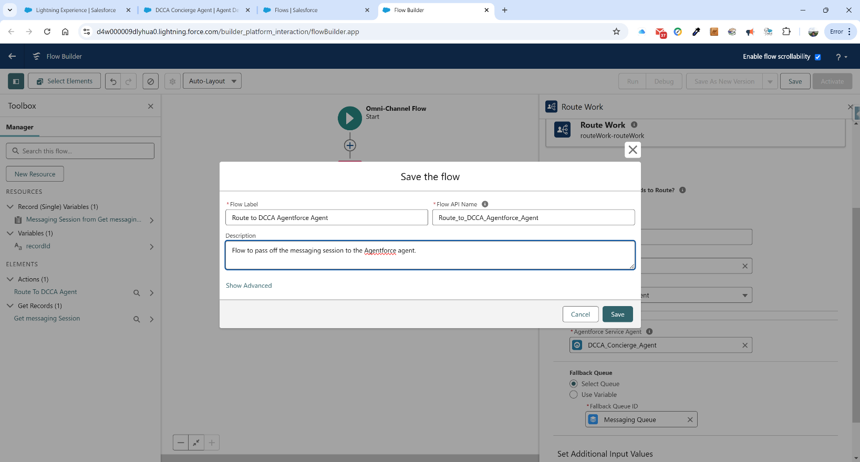

**Flow Label:** Route to DCCA Agentforce Agent

**Description:** Flow to pass off the messaging session to the Agentforce agent.

Click Save. Click Activate.

**Phase IX – Set up MIAW Channel**

Now we return to the Messaging Settings by going to the Quick Find screen and typing in “Messaging Settings”. We click on the link and in the right panel, click on the New Channel button. Click on the Start button.

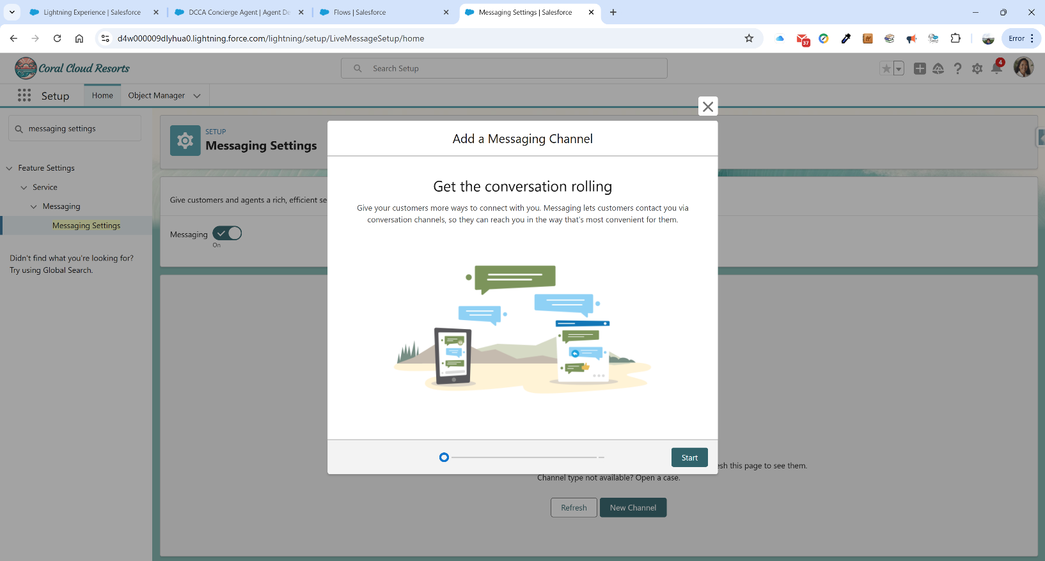

Click on the Messaging for In-App and Web tile.

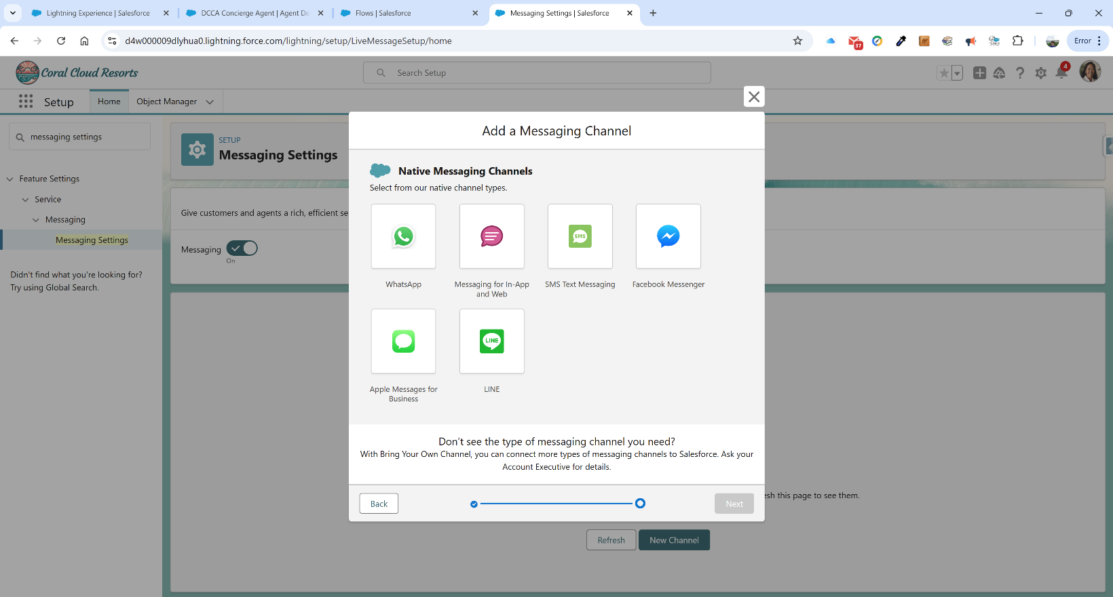

On the next page, type in “Agentforce Channel” for the Channel Name:

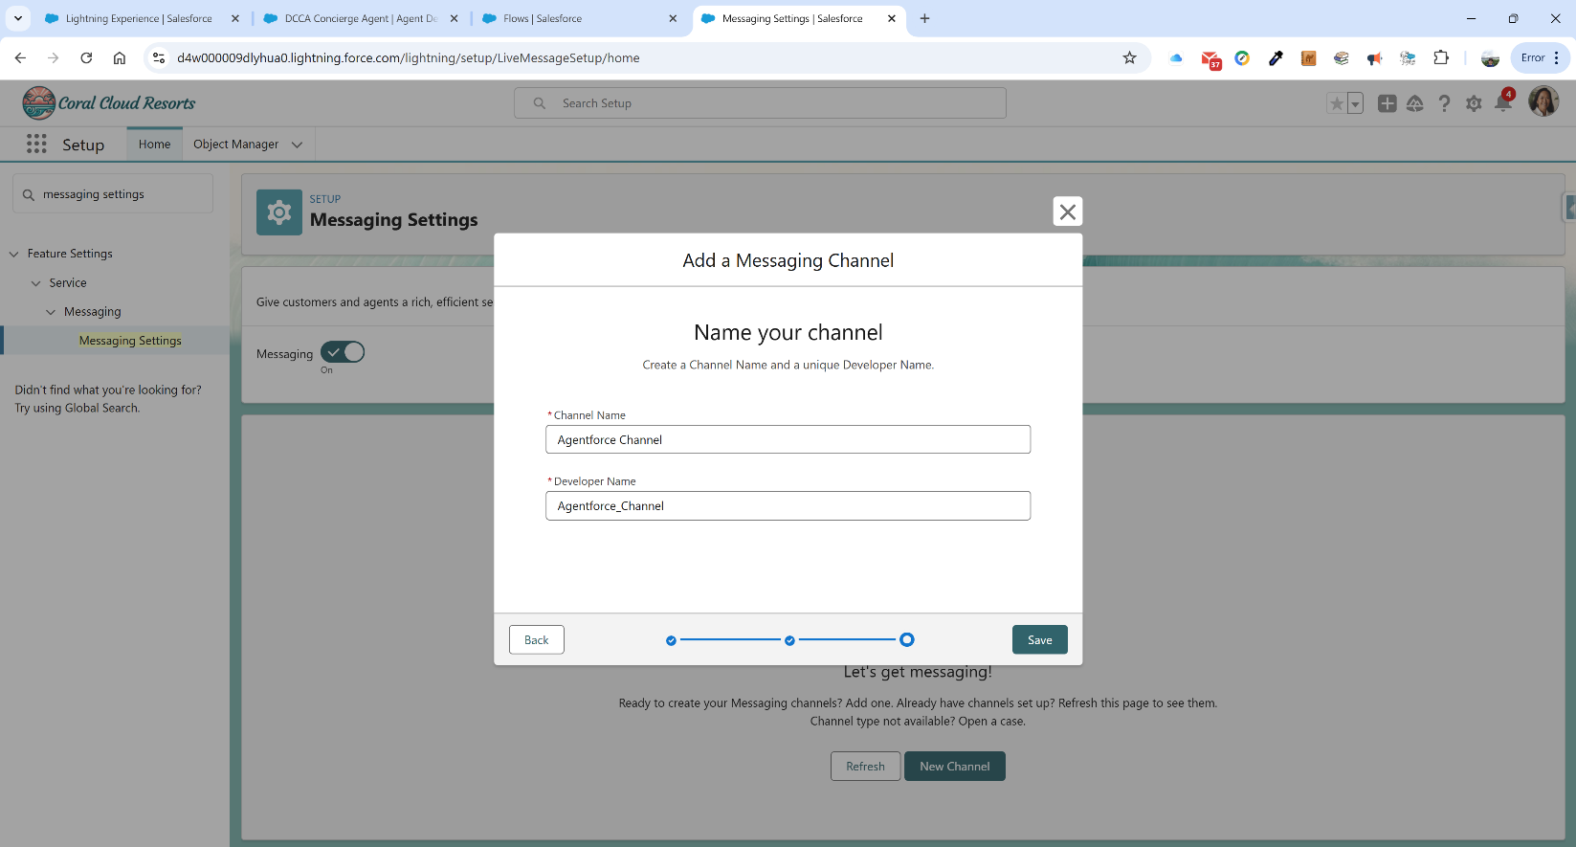

Click Save.

In the following page, update the following lines:

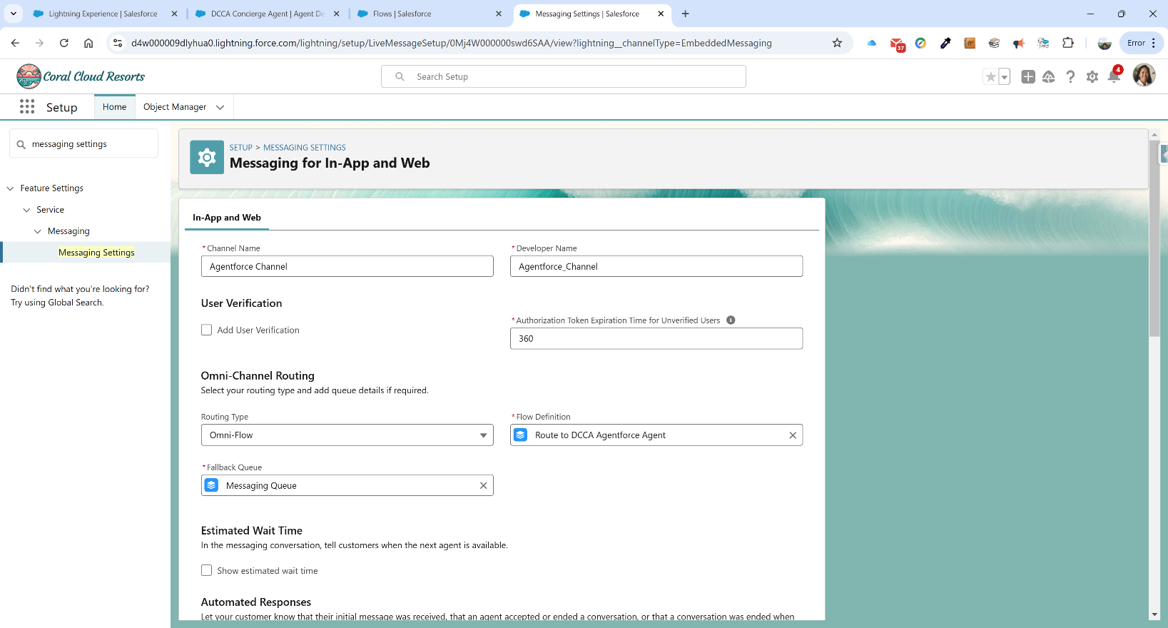

**Routing Type:** Omni Flow

**Flow Definition:** Route to DCCA Agentforce Agent

**Fallback Queue:** Messaging Queue

Click on Save at the bottom of the page. Now that we have saved it, we click on the Messaging Settings in the left panel to go back to the Messaging Settings page. Click on our newly-created Agentforce Channel and click on the Activate button on the top-right corner.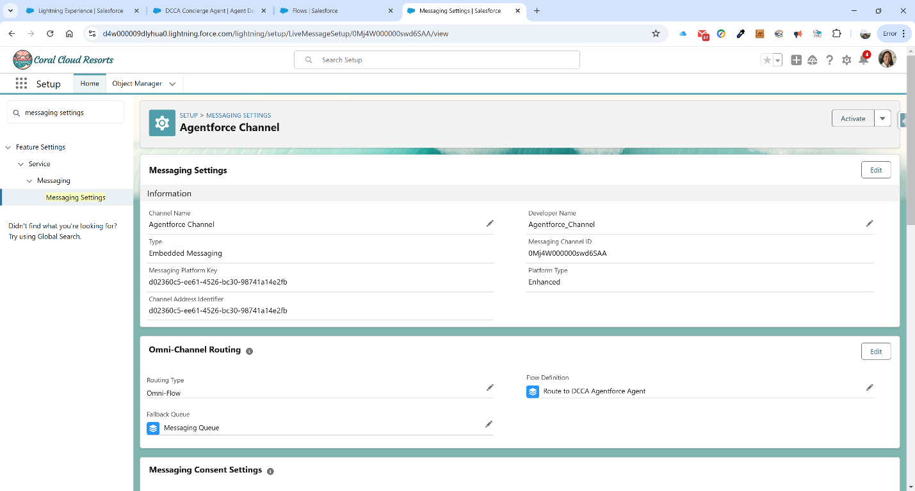

In the modal popup, check the agreement box and click the Accept button:

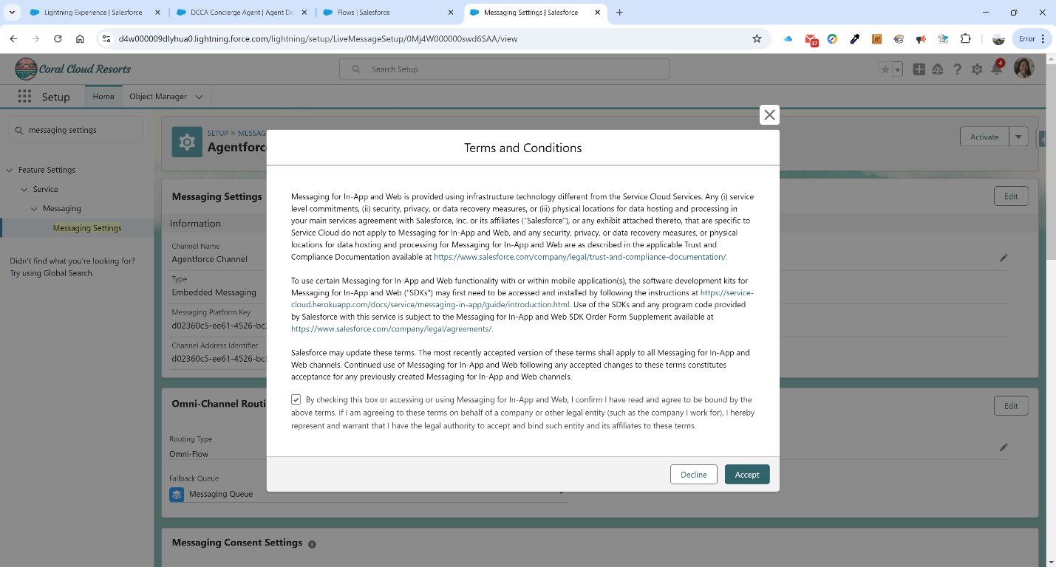

Our Messaging settings are now complete.

**Phase X – Set up New Embedded Deployment**

Now that we have our messaging settings ready, we need to go and set up our embedded deployment to embed the messaging service. Before setting up the deployment, we need to get some information from our Domains section. In Quick Find, type in Domains. Click on the link and note the Domain name next to Experience Cloud Sites Domain. We want to copy that. It is [d4w000009dlyhua0.my.site.com](javascript:srcUp(%27%2F0I44W000000saWW%3FretURL%3D%252F0I4%253FretURL%253D%25252Fsetup%25252Fhome%2526appLayout%253Dsetup%2526tour%253D%2526isdtp%253Dp1%2526sfdcIFrameOrigin%253Dhttps%25253A%25252F%25252Fd4w000009dlyhua0.lightning.force.com%2526sfdcIFrameHost%253Dweb%2526nonce%253D6790598c57ec53e5a4c5b78a10b9f84e5ece920ed36d041a6afd6af3c7b40c65%2526ltn_app_id%253D06m4W0000017iihQAA%2526clc%253D1%26isdtp%3Dp1%27);)

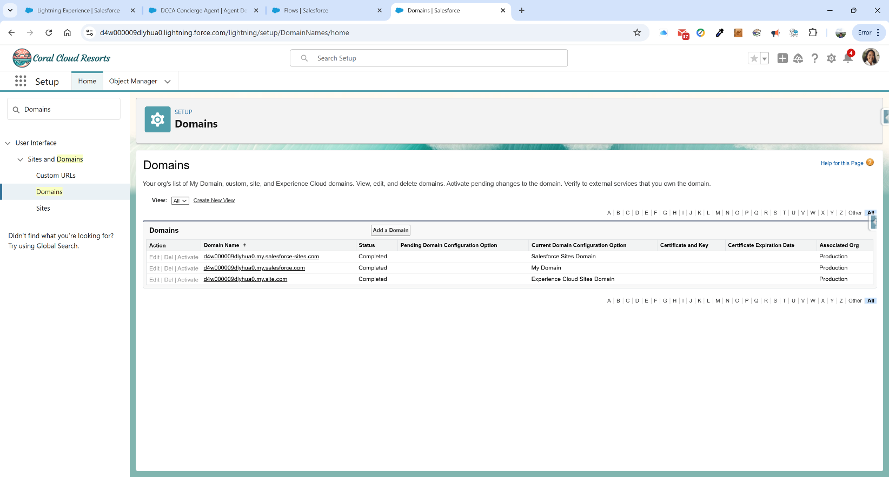

We go back to our Quick Find box and type in Embedded and click on the Embedded Service Deployments link. Click on the New Deployment button. In the modal, select Messaging for In-App and Web and click the Next button:

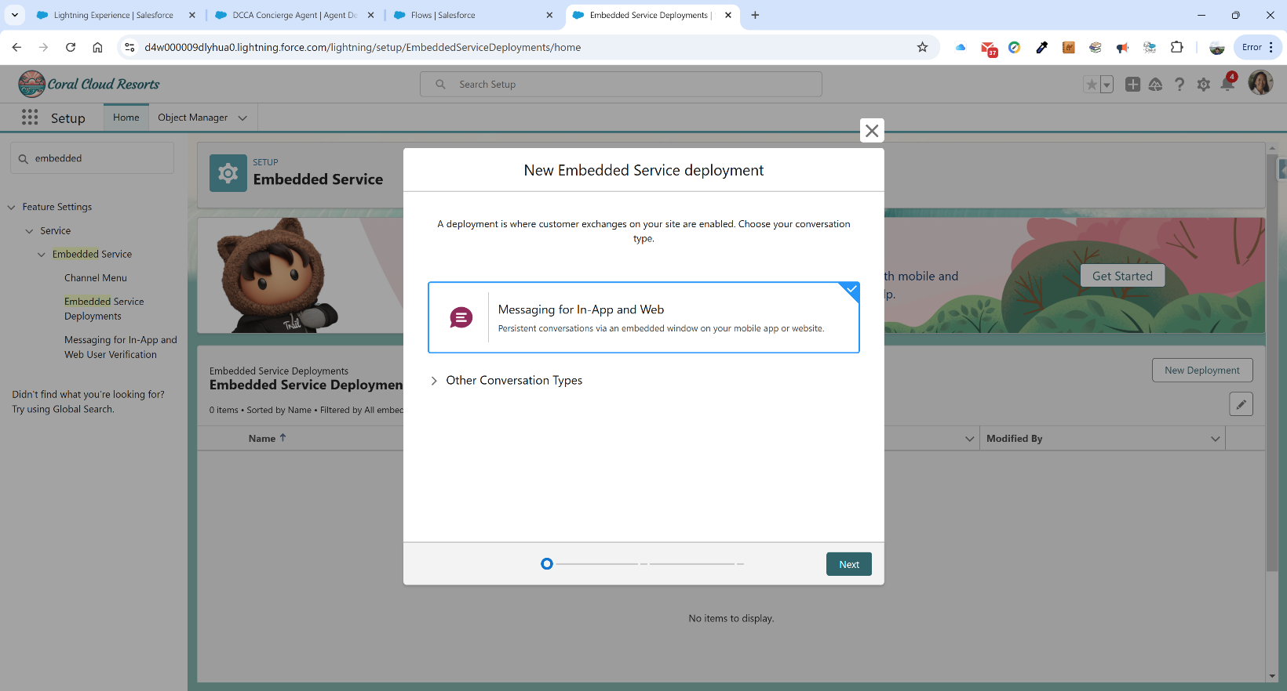

On the next modal window, select Web and click Next:

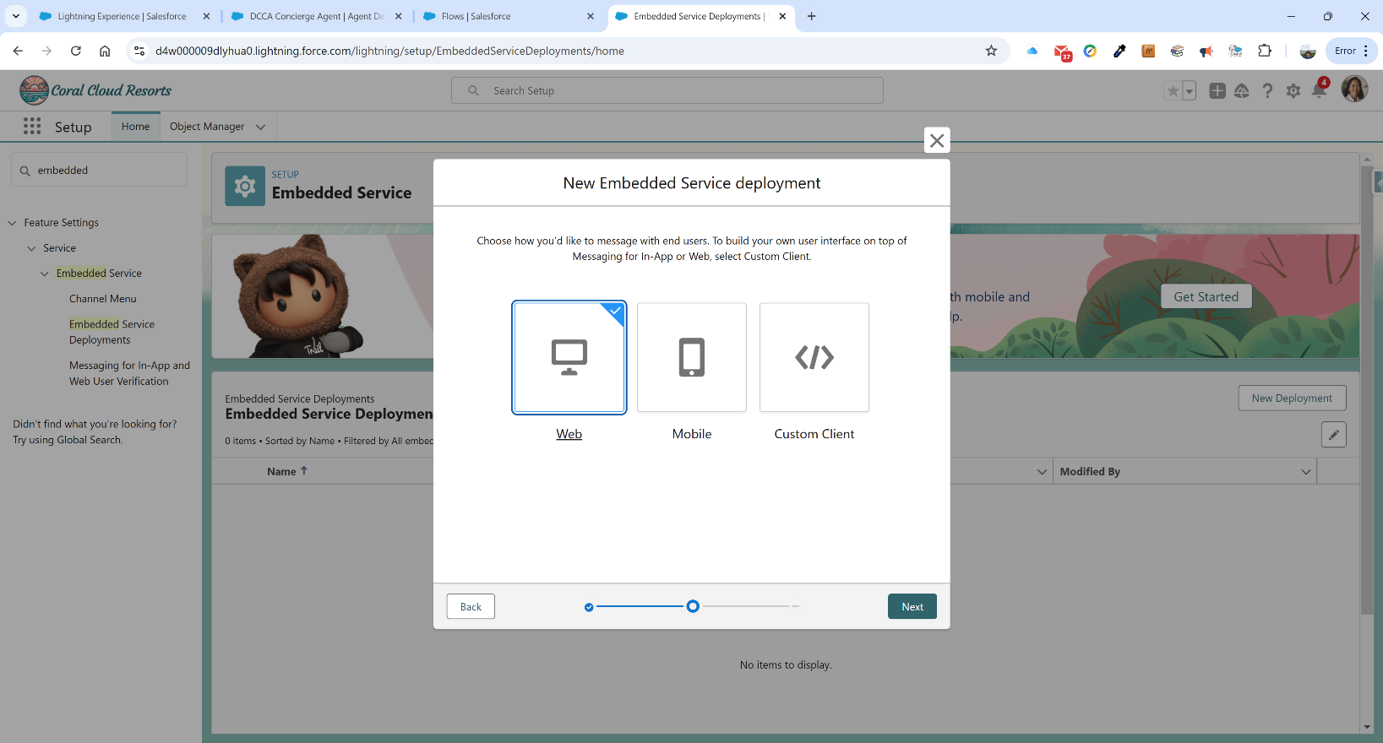

In the next modal window’s form, we type in the following:

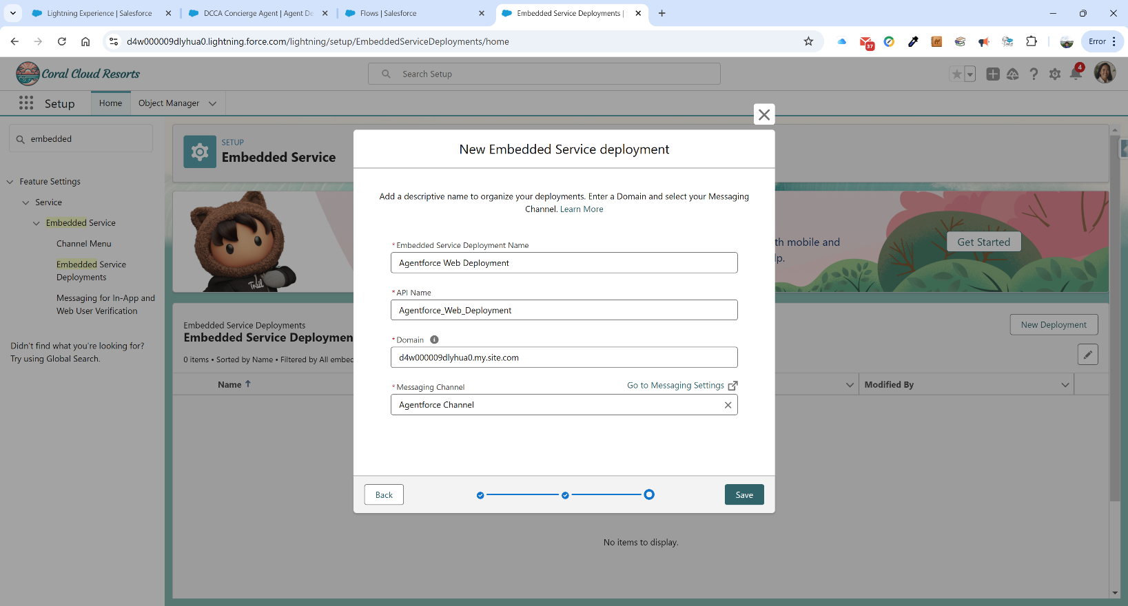

**Embedded Service Deployment Name:** Agentforce Web Deployment

**Domain:** [d4w000009dlyhua0.my.site.com](javascript:srcUp(%27%2F0I44W000000saWW%3FretURL%3D%252F0I4%253FretURL%253D%25252Fsetup%25252Fhome%2526appLayout%253Dsetup%2526tour%253D%2526isdtp%253Dp1%2526sfdcIFrameOrigin%253Dhttps%25253A%25252F%25252Fd4w000009dlyhua0.lightning.force.com%2526sfdcIFrameHost%253Dweb%2526nonce%253D6790598c57ec53e5a4c5b78a10b9f84e5ece920ed36d041a6afd6af3c7b40c65%2526ltn_app_id%253D06m4W0000017iihQAA%2526clc%253D1%26isdtp%3Dp1%27);)

**Messaging Channel:** Agentforce Channel

Click Save. At this point we wait a while for the deployment to complete.

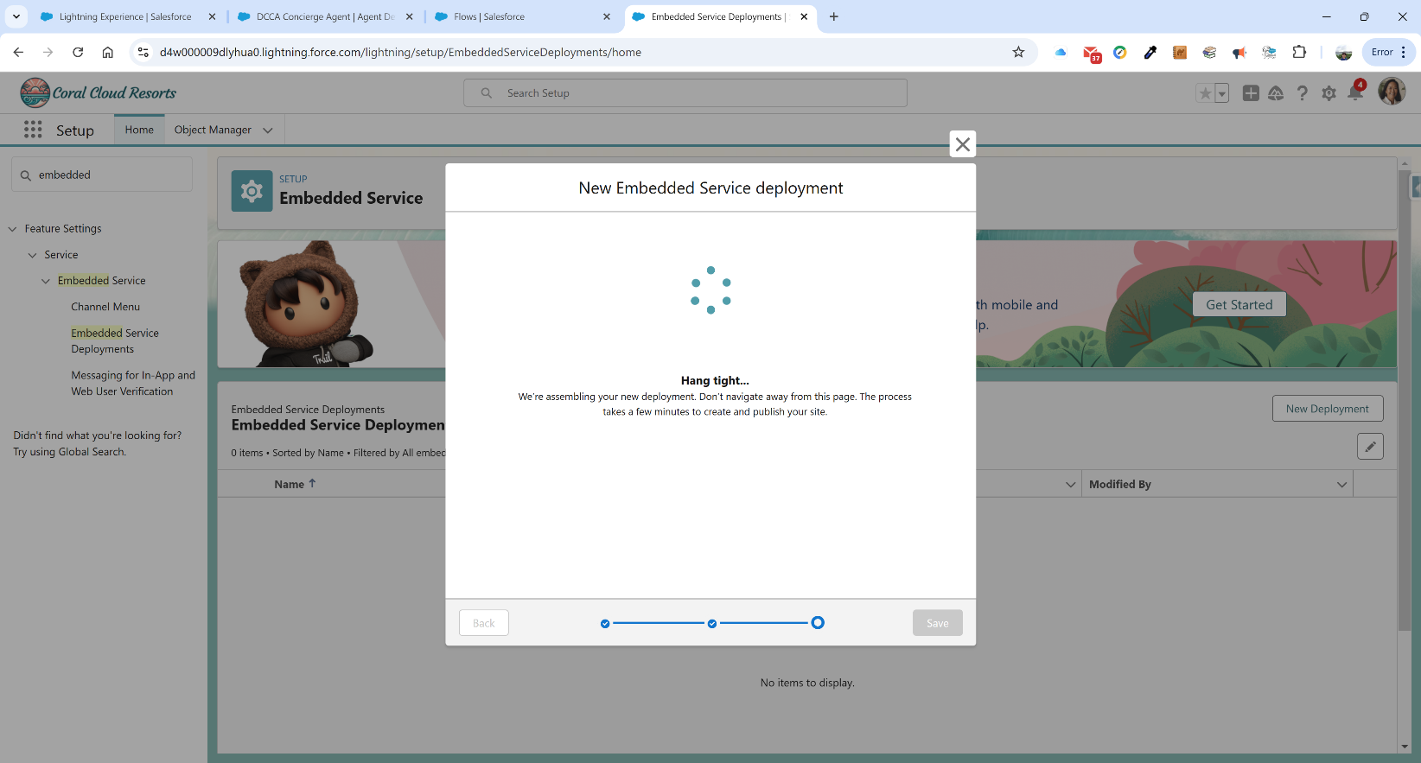

Click on the Settings tile and check the box beside Show typing indicators. This will show the three dots when the agent is “typing”. Click Save.

On the next page, click Publish in the top right corner and wait.

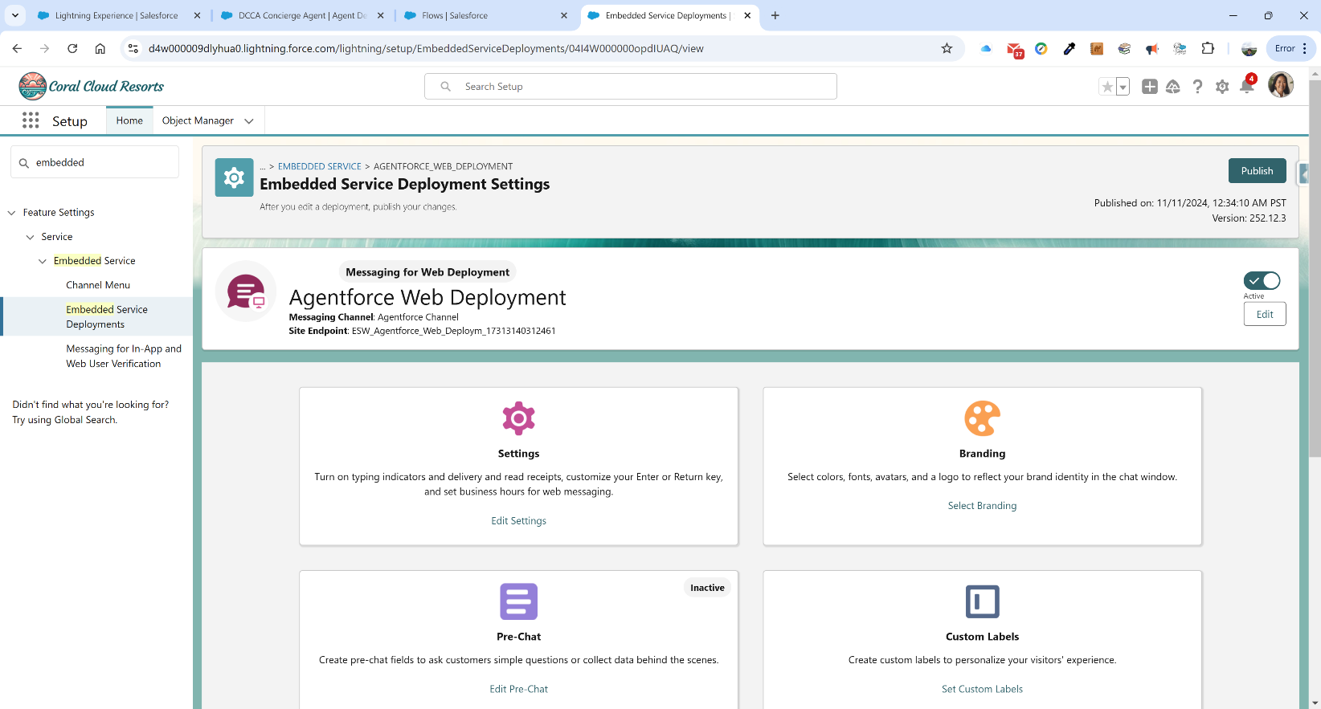

Now we go to Digital Experiences by typing All Sites into the Quick Find. We can see that we have the coral cloud Digital Experiences site as well as the agent deployment we just created.

**Phase XI – Set up Community Site(Digital Experience)**

We now want to set up our own digital experience site. We click on the New button. We will choose the Citizen template.

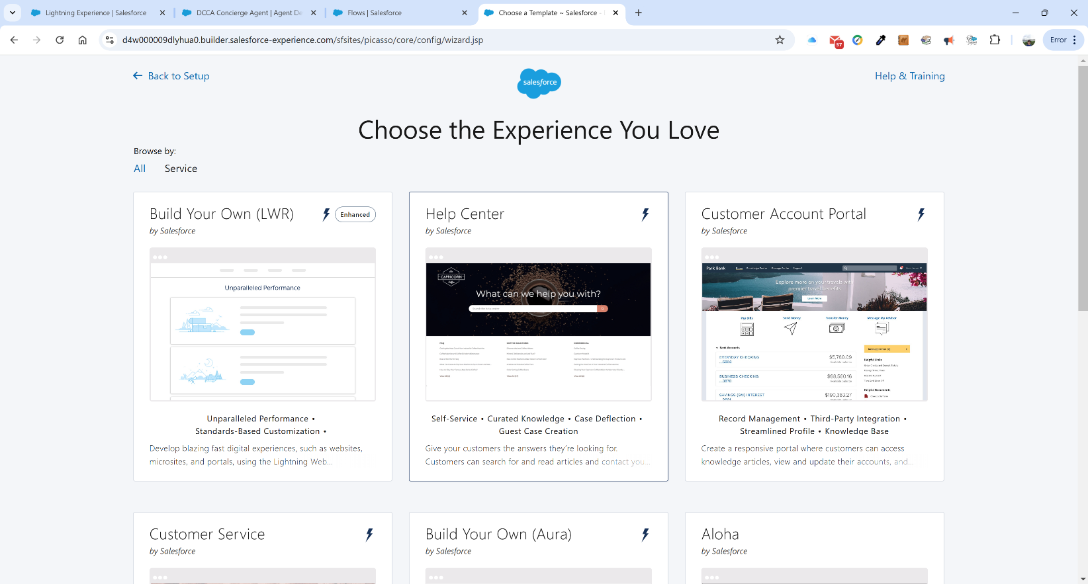

We then click on Get Started and we type in State of Hawaii – DCCA as our Name and tag on dcca as the URL.

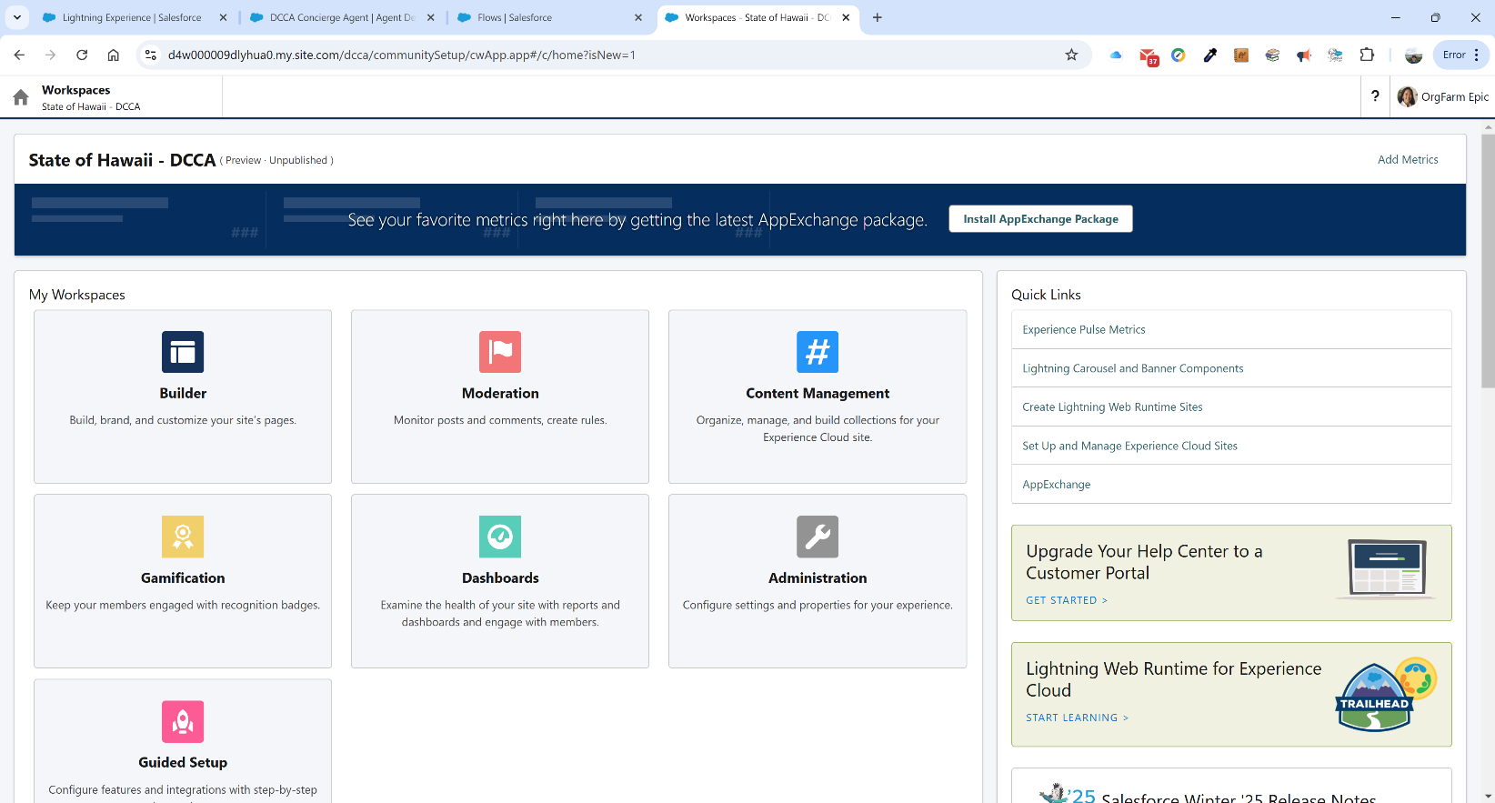

We now click on the Builder tile.

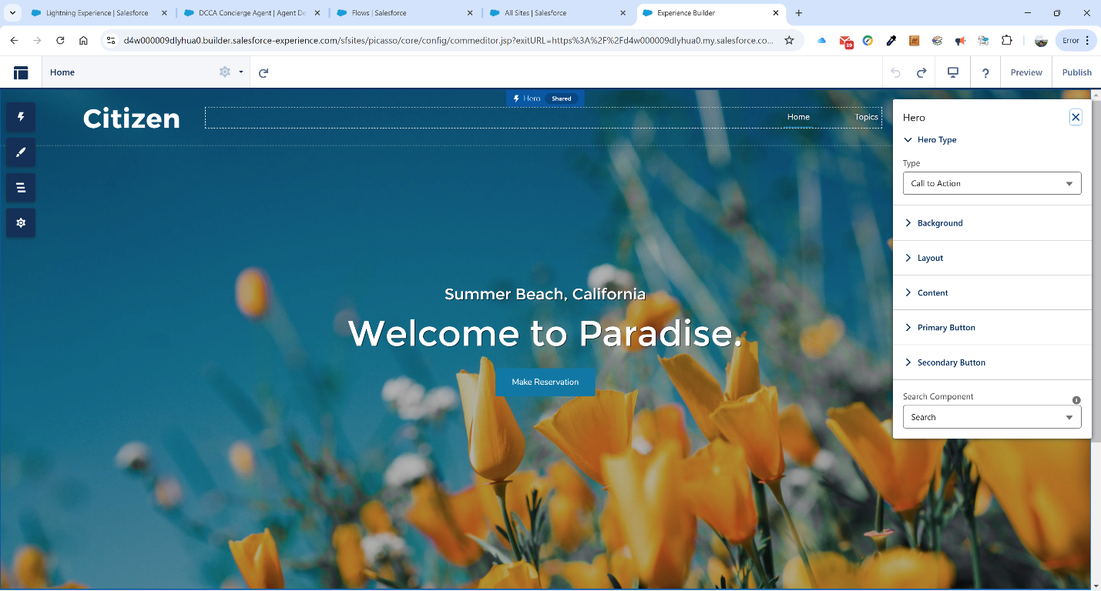

We have a couple of settings to complete. In Settings, under General, we need to make sure that “Guest users can see and interact with the site without logging in” is checked.

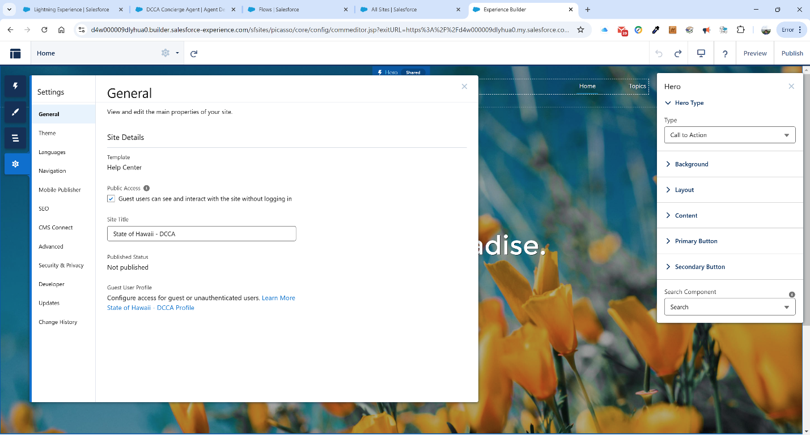

We now want to add an embedded messaging component. We click on the Component icon(lightning) in the left-hand navigation bar. In the search bar, type in “Embedded” and then drag and drop the Embedded Messaging component onto the canvas.

Click on the component you just added and the following configuration screen appears:

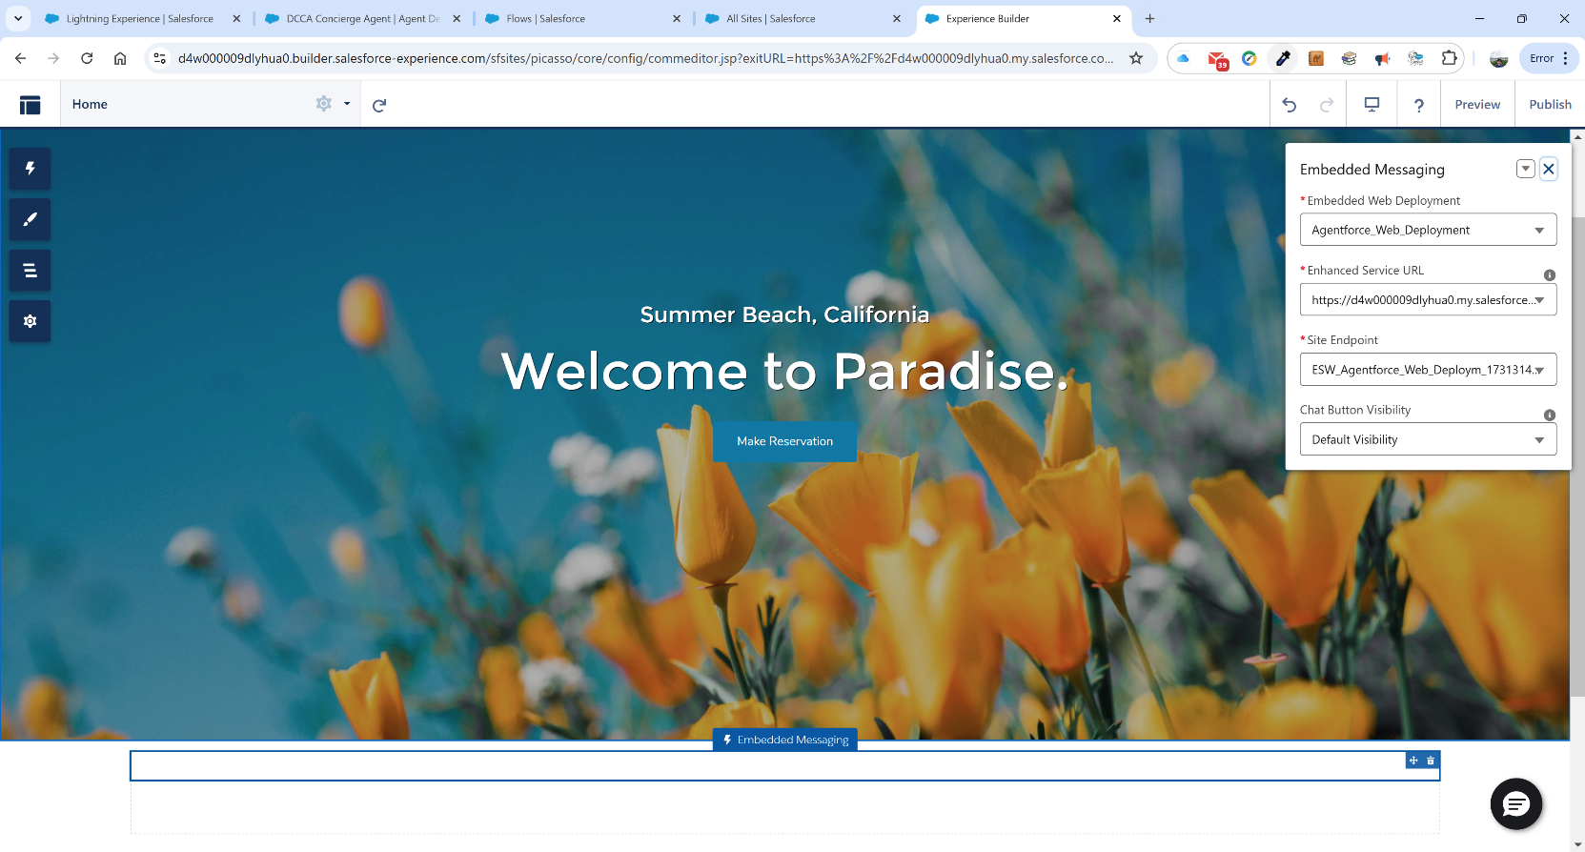

The defaults are correct. We now click the Publish button in the top right corner. The following warning pops up. Click Publish:

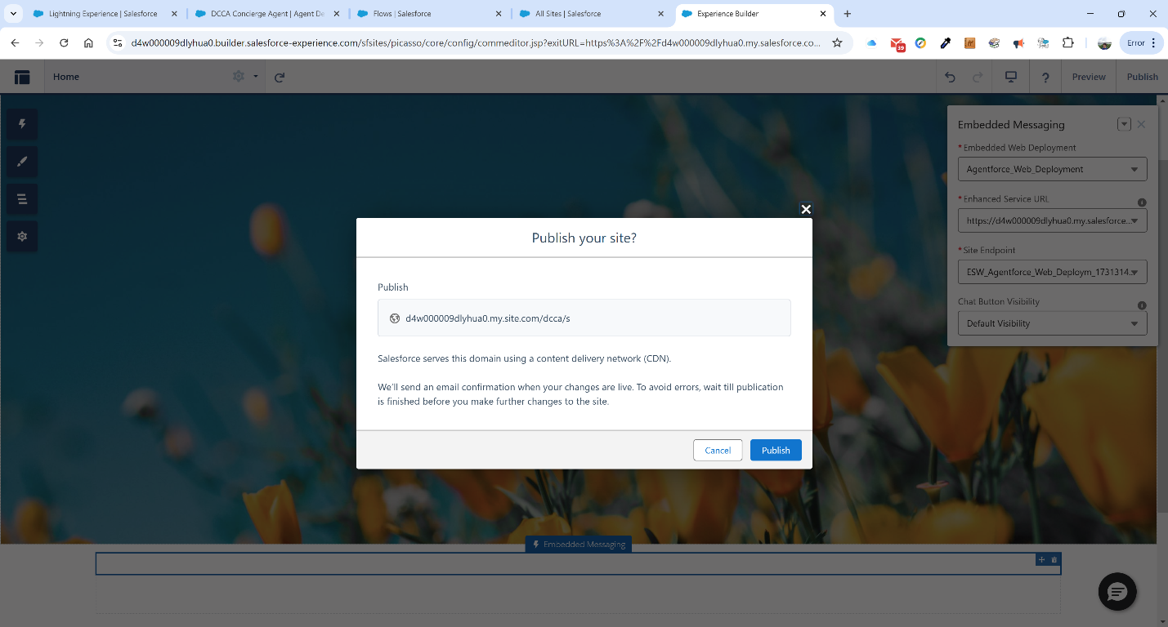

After publishing, we need to activate the site in the Administration page. We click on the icon in the top left corner. That brings up a menu, from which we will select “Administration”.

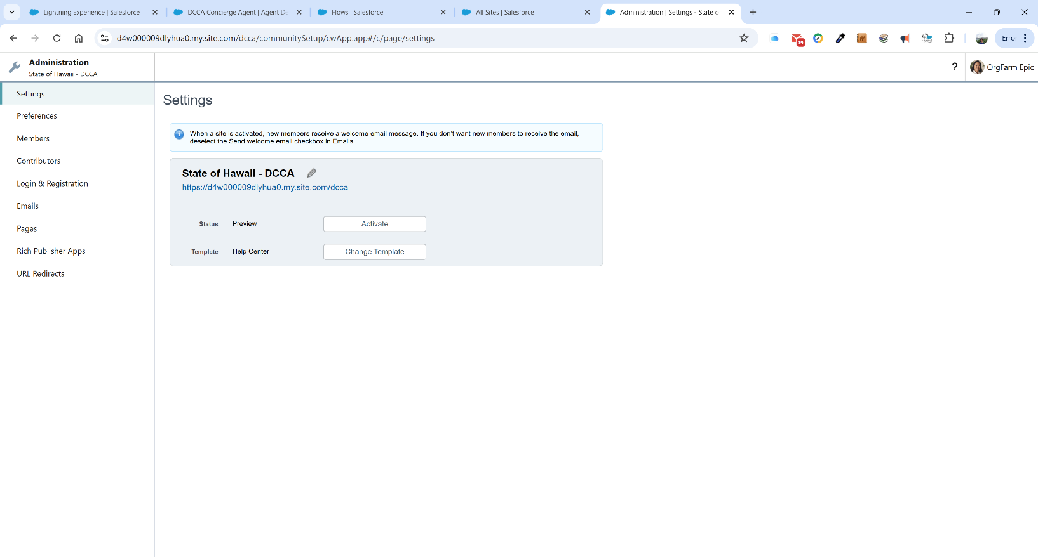

On this page, we click on the Activate button. We can now click on the messaging icon in the bottom right corner of the screen and type in questions:

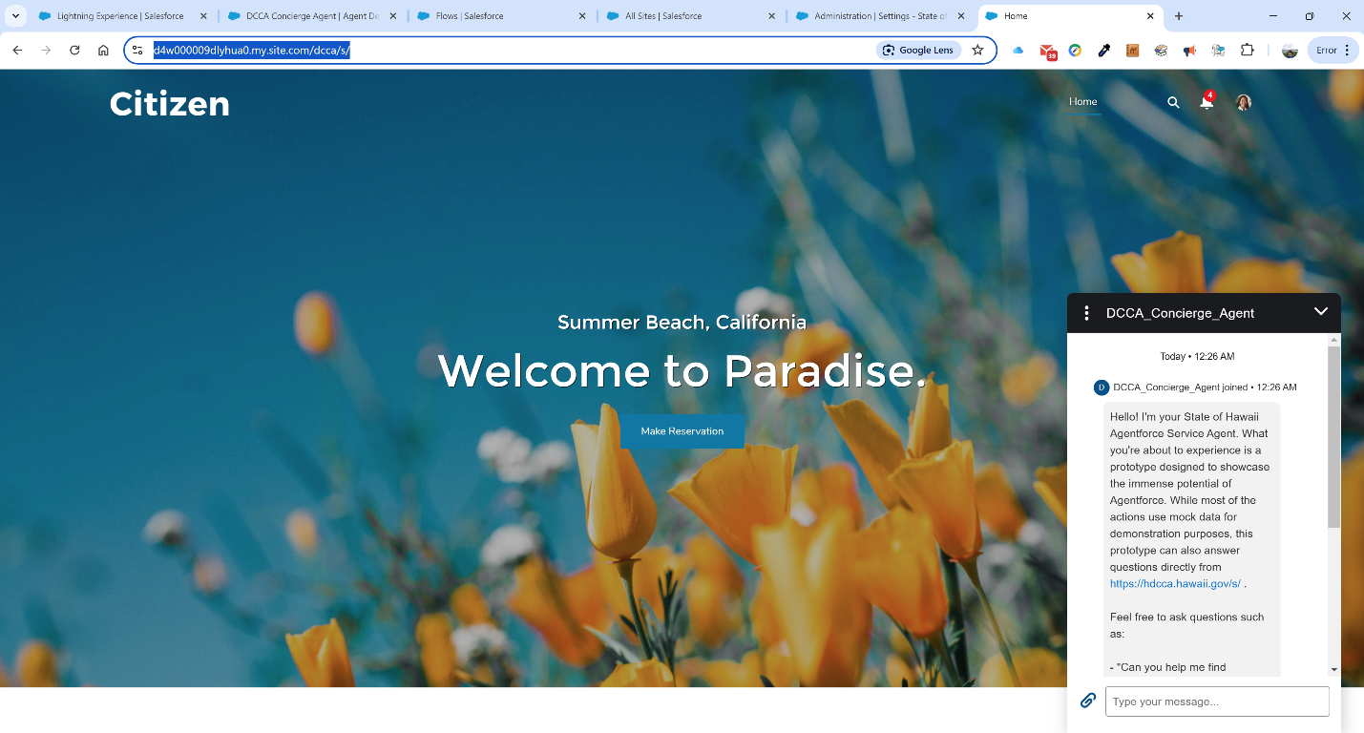

Obviously, we need to change the graphics a bit, but we now have a working AI chatbot agent awaiting our every question. Except insurance, because insurance is SO boring.